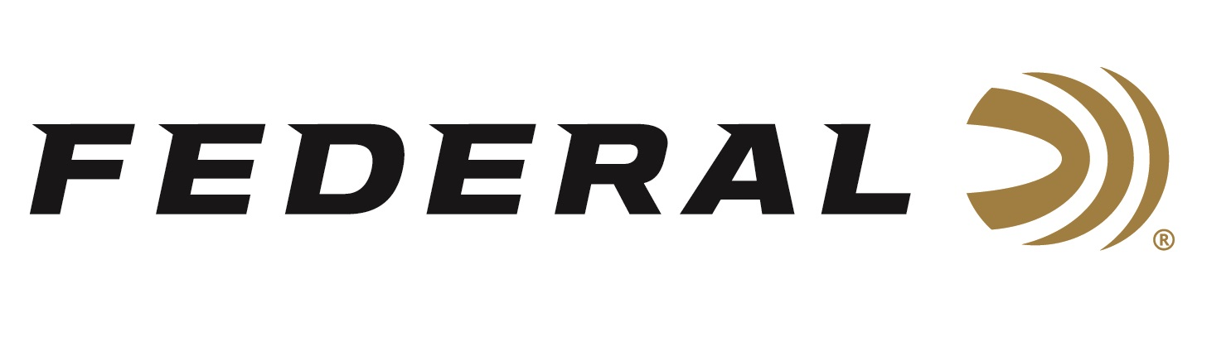

FOR IMMEDIATE RELEASE

Team Federal Shooters Win Trap and Skeet Medals at the
2022 XIII CAT Championships

ANOKA, Minnesota – November 14, 2022 – Team Federal congratulates its team members Caitlin Connor and Kayle Browning for their medal performances in Women’s Trap and Skeet at the XIII CAT Championships 2022, recently held in Lima, Peru.

At the event, Browning was the Silver Medalist in Women’s Trap. Connor was a Bronze Medalist in Women’s Skeet. American women also grabbed a Paris 2024 Olympic quota berth in the Women's Trap competition.

“We are extremely proud of the performances from Caitlin and Kayle, as well as our other Team Federal athletes who competed at this prestigious, worldwide event,” said Federal Ammunition’s Vice President of Marketing Jason Nash.

Earlier this year, Browning was the 2022 Lima World Cup Gold Medalist in Women's Trap Team and Bronze Medalist in Mixed Trap Team. Connor was the 2022 World Cup Lonato 3-time Gold Medalist in Women's Skeet, Women's Skeet Team, and Mixed Skeet; 2022 World Cup Lima Gold Medalist in Women's Skeet Team and Bronze in Mixed Skeet; as well as the 2022 World Cup Cyprus Silver Medalist in Mixed Skeet team, and silver in 3-Woman Skeet team.

Federal ammunition can be found at dealers nationwide or purchased online direct. For more on Federal ammunition, visit www.federalpremium.com.

Press Release Contact: JJ Reich
Senior Manager – Press Relations
E-mail: VistaPressroom@VistaOutdoor.com

About Federal Ammunition
Federal, headquartered in Anoka, MN, is a brand of Vista Outdoor Inc., an outdoor sports and recreation company. From humble beginnings nestled among the lakes and woods of Minnesota, Federal Ammunition has evolved into one of the world's largest producers of sporting ammunition. Beginning in 1922, founding president, Charles L. Horn, paved the way for our success. Today, Federal carries on Horn's vision for quality products and service with the next generation of outdoorsmen and women. We maintain our position as experts in the science of ammunition production. Every day we manufacture products to enhance our customers' shooting experience while partnering with the conservation organizations that protect and support our outdoor heritage. We offer thousands of options in our Federal Premium and Federal® lines-it's what makes us the most complete ammunition company in the business and provides our customers with a choice no matter their pursuit.

