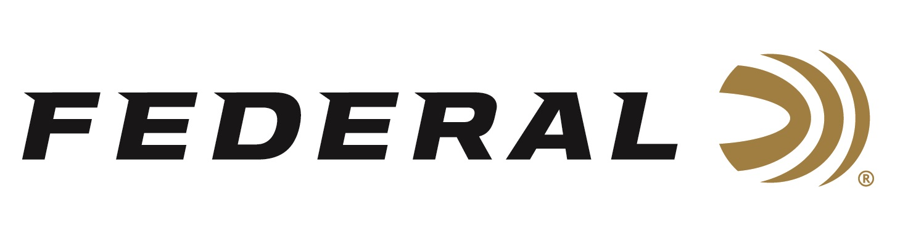

FOR IMMEDIATE RELEASE

Trap Shooters on Team Federal Win Medals at the 2022 ISSF World Cup

ANOKA, Minnesota – April 4, 2022 – Team Federal congratulates its team members Kayle Browning and Derrick Mein for their medal performances in Trap at the ISSF World Cup held in Lima, Peru, March 27 to April 7.

“We are extremely proud of the stellar performances from Mein and Browning, as well as our other Team Federal athletes who competed at this prestigious, worldwide event,” said Federal Ammunition’s Vice President of Marketing Jason Nash. “Their accomplishments are a reflection of Federal’s dedication to its quality products and to the shooting sports.”

Tokyo Olympic silver medalist Kayle Browning won a gold medal at the Trap Team Woman’s event. She also won a silver medal in the Woman’s Trap event and a bronze medal in the Mixed Team Trap event, paired with Derek Haldeman. Derrick Mein won his first ISSF competition medal, a bronze, in the Men’s Trap event. The champion shooter was also a part of the U.S.A. Men’s Trap Team gold medal performance over Spain.

“Mein and Browning are certainly two of the top trap shooters in our country and also represented the U.S.A. in Tokyo last year,” continued Nash. “This was a great start for Team Federal. We are eager and excited to see their performances—and all our sponsored shooters—during many competitions they will shoot this year.”

Federal ammunition can be found at dealers nationwide or purchased online direct. For more on Federal ammunition, visit www.federalpremium.com.

Press Release Contact: JJ Reich
Senior Manager – Press Relations
E-mail: VistaPressroom@VistaOutdoor.com

About Federal Ammunition
Federal, headquartered in Anoka, MN, is a brand of Vista Outdoor Inc., an outdoor sports and recreation company. From humble beginnings nestled among the lakes and woods of Minnesota, Federal Ammunition has evolved into one of the world's largest producers of sporting ammunition. Beginning in 1922, founding president, Charles L. Horn, paved the way for our success. Today, Federal carries on Horn's vision for quality products and service with the next generation of outdoorsmen and women. We maintain our position as experts in the science of ammunition production. Every day we manufacture products to enhance our customers' shooting experience while partnering with the conservation organizations that protect and support our outdoor heritage. We offer thousands of options in our Federal Premium and Federal® lines-it's what makes us the most complete ammunition company in the business and provides our customers with a choice no matter their pursuit.

