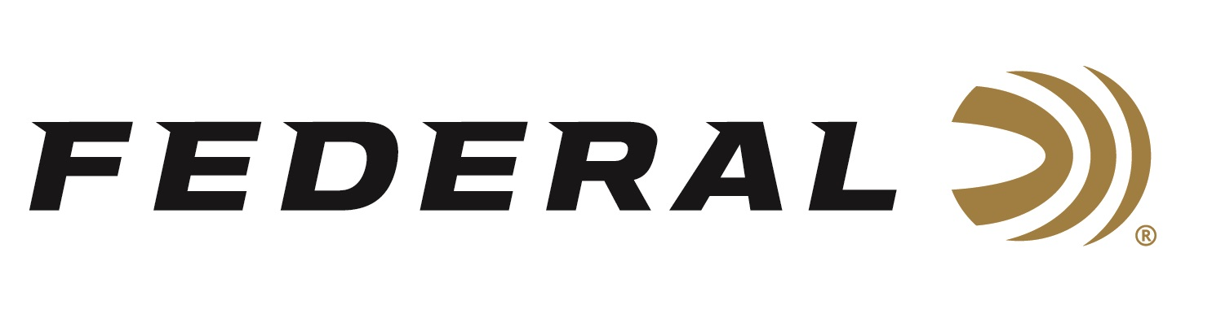
FOR IMMEDIATE RELEASE

Federal Ammunition: 10 Years of Offering Personal Defense HST

ANOKA, Minnesota – December 6, 2023 – Federal Ammunition, the industry's ammunition technology leader, acknowledges a 10th-year milestone in offering its Personal Defense HST ammunition to the commercial self-defense market. Personal Defense HST is for consumers who demand consistent expansion, optimum penetration and superior terminal performance in self-defense rounds that are proven by law enforcement experience.

Personal Defense HST | Federal Premium

“For decades, our Federal Premium HST handgun ammunition has been a trusted duty load for law enforcement officers around the world,” said Federal Ammunition’s Senior Director of Product Development, Jesse Whiteside. “In 2013, we started offering this ammunition—the pinnacle for self-defense attributes, including consistent expansion, optimum penetration, and superior terminal performance—to the everyday, conceal-carry customer.”

Federal Premium HST is proven in FBI test protocols. It features a specially-designed hollow point that will not plug while passing through a variety of barriers and a jacket and core that hold together while penetrating even the toughest materials.

“In 2013, we released three loads to the commercial market,” continued Whiteside. “Today our HST lineup has increased to eleven loads. We now offer it in four different 9mm loads as well as 45 Auto +P, 357 Sig, 10mm Auto, 38 Special +P, and several more, all of which are in high demand.”

The expanded diameter and near 100% weight retention produce the desired performance for personal defense situations without over-penetrating. Plus, the bullet’s nose profile, nickel-plated case and Federal's unique primer provide the ultimate in function and reliability in semi-automatic handguns.

“HST is for anyone who will trust nothing but the best to protect their lives and those of loved ones,” said Whiteside. “We are proud of the last 10 years of this product line’s performance in law enforcement and commercial applications. Sales of this product have exceeded expectations, and we anticipate more great things from HST in the next 10 years and beyond.”

For more information on all products from Federal or to shop online, visit www.federalpremium.com.

Press Release Contact: JJ Reich
Senior Manager – Press Relations
E-mail: VistaPressroom@VistaOutdoor.com

About Federal Ammunition
Federal, headquartered in Anoka, MN, is a brand of Vista Outdoor Inc., an outdoor sports and recreation company. From humble beginnings nestled among the lakes and woods of Minnesota, Federal Ammunition has evolved into one of the world's largest producers of sporting ammunition. Beginning in 1922, founding president, Charles L. Horn, paved the way for our success. Today, Federal carries on Horn's vision for quality products and service with the next generation of outdoorsmen and women. We maintain our position as experts in the science of ammunition production. Every day we manufacture products to enhance our customers' shooting experience while partnering with the conservation organizations that protect and support our outdoor heritage. We offer thousands of options in our Federal Premium and Federal® lines-it's what makes us the most complete ammunition company in the business and provides our customers with a choice no matter their pursuit.

