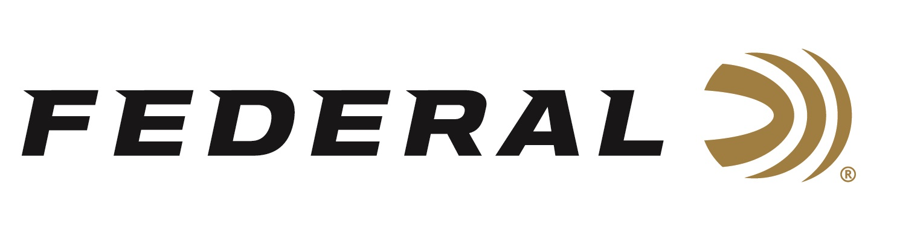

FOR IMMEDIATE RELEASE

Federal Sponsored Shooters Derrick Mein and Vincent Hancock Win
2023 World Cup Selections

ANOKA, Minnesota – February 15, 2023 – Federal Ammunition congratulates sponsored shooters and USA Shooting athletes Derrick Mein and Vincent Hancock for winning 2023 World Cup selections. The accomplishments occurred at the Shotgun Spring Selection Match that took place February 3-8 in Tuscon, Arizona.

“The weather conditions made it a tough battle,” said Mein. “Several members of the national team pushed me pretty hard, making it a tight race. Multiple spots on the team were decided by a shoot-off after the final. It was a thrilling event.”

With the wins, both Mein and Hancock earned the right to represent the USA at the World Cup in Doha, Qatar in March; the World Cup in Larnaca, Cyprus in late March; and the French Grand Prix in Paris, France in late April. Hancock will lead the Men’s Skeet National Team and Mein will lead the Men’s Trap National Team at those three Spring World Cup events.

“My Federal High Over All 24-gram shotshells helped pull me through a couple tough days of wind,” explained Mein. “Knowing I was using the best ammunition allowed me to focus on breaking targets and not worrying about the environment.”

Federal ammunition can be found at dealers nationwide. For more on Federal ammunition or to shop online, visit www.federalpremium.com.

Press Release Contact: JJ Reich
Senior Manager – Press Relations
E-mail: VistaPressroom@VistaOutdoor.com

About Federal Ammunition
Federal, headquartered in Anoka, MN, is a brand of Vista Outdoor Inc., an outdoor sports and recreation company. From humble beginnings nestled among the lakes and woods of Minnesota, Federal Ammunition has evolved into one of the world's largest producers of sporting ammunition. Beginning in 1922, founding president, Charles L. Horn, paved the way for our success. Today, Federal carries on Horn's vision for quality products and service with the next generation of outdoorsmen and women. We maintain our position as experts in the science of ammunition production. Every day we manufacture products to enhance our customers' shooting experience while partnering with the conservation organizations that protect and support our outdoor heritage. We offer thousands of options in our Federal Premium and Federal® lines-it's what makes us the most complete ammunition company in the business and provides our customers with a choice no matter their pursuit.

