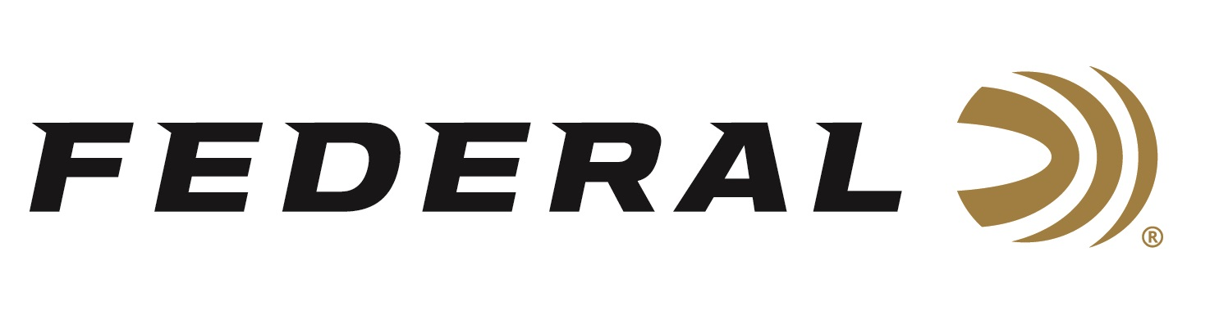

FOR IMMEDIATE RELEASE

Federal Ammunition Launches New Power-Shok 360 Buckhammer

ANOKA, Minnesota – November 3, 2023 – Federal Ammunition adds the new 360 Buckhammer cartridge to its Power-Shok product line. 360 Buckhammer is a brand new straight-wall cartridge recently launched by Remington Ammunition. It is specifically designed for lever-actions and is deadly-accurate past 200 yards. This new product is shipping to dealers and is available.

Power-Shok Rifle 360 Buckhammer | Federal Ammunition

“The tag-filling efficiency of Federal Power-Shok has made it a legend in hunting camps ranging from the Northwoods to the mountains and everywhere in between,” said Federal’s Centerfire Ammunition Product Line Manager Eric Miller. “Our traditional lead-core hunting bullets offer accurate performance at an affordable price. It is a great combination for this new cartridge. We certainly are excited to offer it in 360 Buckhammer.”

The two Power-Shok offerings in the all-new 360 Buckhammer cartridge are 180- and 200-grain jacketed soft-point bullets. The 180-grain option is currently available, and the 200-grain option is coming soon. The .358 diameter bullet delivers energy and trajectory like 30-30 Win., with softer recoil for better accuracy in the field.

Summary of features include: New 360 Buckhammer cartridge specially designed for lever-action rifles; .358 diameter bullet provides ballistics and power like 30-30 Win., with softer recoil; Straight-wall cartridge legal in more previously slug-only areas; Jacketed soft-point bullet; 20-round boxes; MSRP: $36.99.

For more information on all products from Federal or to shop online, visit www.federalpremium.com.

Press Release Contact: JJ Reich
Senior Manager – Press Relations
E-mail: VistaPressroom@VistaOutdoor.com

About Federal Ammunition
Federal, headquartered in Anoka, MN, is a brand of Vista Outdoor Inc., an outdoor sports and recreation company. From humble beginnings nestled among the lakes and woods of Minnesota, Federal Ammunition has evolved into one of the world's largest producers of sporting ammunition. Beginning in 1922, founding president, Charles L. Horn, paved the way for our success. Today, Federal carries on Horn's vision for quality products and service with the next generation of outdoorsmen and women. We maintain our position as experts in the science of ammunition production. Every day we manufacture products to enhance our customers' shooting experience while partnering with the conservation organizations that protect and support our outdoor heritage. We offer thousands of options in our Federal Premium and Federal® lines-it's what makes us the most complete ammunition company in the business and provides our customers with a choice no matter their pursuit.

