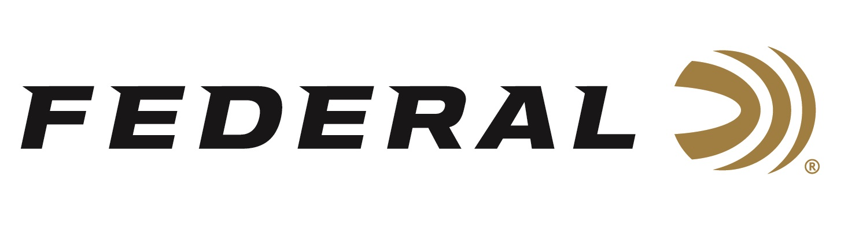

FOR IMMEDIATE RELEASE

Federal Adds 360 Buckhammer Its Popular Power-Shok Rifle Ammunition Product Line

ANOKA, Minnesota – January 16, 2023 – Federal Ammunition adds two Power-Shok rifle loads in the new 360 Buckhammer cartridge. The 180-grain and 200-grain Jacketed Soft Point (JSP) are .358 in diameter and delivers energy and trajectory that match the 30-30 Win., with softer recoil and better accuracy. This brand new straight-wall cartridge—recently launched by Remington Ammunition—is specifically designed for lever-actions and is deadly-accurate past 200 yards. This new product announcement was made at the 2023 SHOT Show in Las Vegas, Nevada.

“Decades of reliability and efficiency of Federal Power-Shok JSPs are what has made this product line a legend within hunting camps worldwide,” said Jesse Whiteside, Federal's Product Management Senior Director. “Two offerings, 180- and 200-grain, in the all-new 360 Buckhammer cartridge are sure to impress lever-gun hunters who set their sights on big game.”

Summary of features include: New 360 Buckhammer cartridge specially designed for lever-action rifles; .358 diameter bullet provides ballistics and power like 30-30 Win., with softer recoil; straight-wall cartridge legal in more previously slug-only areas; Jacketed soft-point bullet; Available in 180- and 200-grain options: MSRP: $36.99, 20-round boxes.

“Our new Buckhammer cartridge meets the needs of a growing market opportunity due to changing laws in traditional shotgun/muzzleloader states,” continued Whiteside. “Within the last five years, several prominent deer-hunting states have passed laws allowing straight-wall cartridges in zones previously designated as shotgun- or muzzleloader-only. The new Buckhammer cartridge adds to the straight-wall list of choices while providing hunters with a powerful and ballistically superior new option.”

For more information on all products from Federal or to shop online, visit www.federalpremium.com.

Press Release Contact: JJ Reich
Senior Manager – Press Relations
E-mail: VistaPressroom@VistaOutdoor.com

About Federal Ammunition
Federal, headquartered in Anoka, MN, is a brand of Vista Outdoor Inc., an outdoor sports and recreation company. From humble beginnings nestled among the lakes and woods of Minnesota, Federal Ammunition has evolved into one of the world's largest producers of sporting ammunition. Beginning in 1922, founding president, Charles L. Horn, paved the way for our success. Today, Federal carries on Horn's vision for quality products and service with the next generation of outdoorsmen and women. We maintain our position as experts in the science of ammunition production. Every day we manufacture products to enhance our customers' shooting experience while partnering with the conservation organizations that protect and support our outdoor heritage. We offer thousands of options in our Federal Premium and Federal® lines-it's what makes us the most complete ammunition company in the business and provides our customers with a choice no matter their pursuit.

