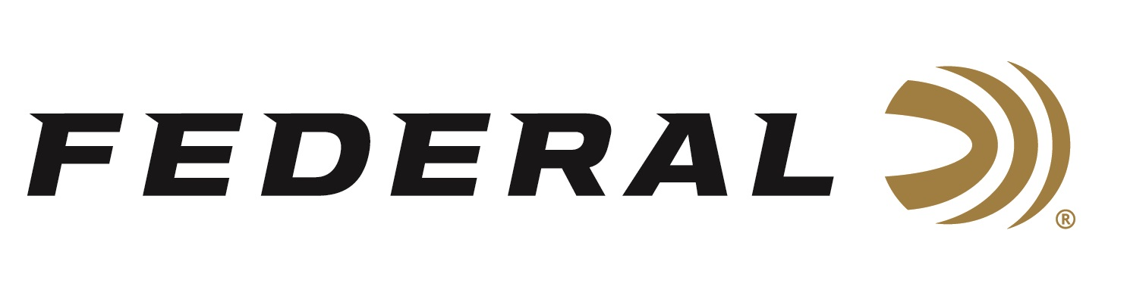

FOR IMMEDIATE RELEASE

Federal Ammunition Awarded 223 Rem. Duty Ammo Contract with the Department of Homeland Security, U.S. Immigration and Customs Enforcement

ANOKA, Minnesota – October 19, 2023 – The Department of Homeland Security (DHS), U.S. Immigration and Customs Enforcement (ICE) has selected the Federal Premium Law Enforcement Ammunition brand as the contract awardee for their 223 Rem. rifle ammunition. DHS, ICE protects America through criminal investigations and enforcing immigration laws to preserve national security and public safety. ICE has more than 20,000 law enforcement and support personnel in more than 400 offices in the United States and around the world.

The selected cartridge is the Tactical Bonded 62-grain soft point. This single-award, Indefinite Delivery Indefinite Quantity contract is a Strategically Sourced contract for all DHS components and other federal agencies with a maximum quantity of 28 million rounds. The ordering period is for a total of five years.

“Law enforcement and federal agencies put it all on the line for our safety and freedoms. They should expect nothing less from their ammunition. We are proud to provide the highest quality duty ammunition to ICE agents in the field,” said Federal Ammunition President Jason Vanderbrink. “Federal Premium Law Enforcement provides the top-quality products officers and agents need to have full confidence in any situation. Tactical Bonded has a long history of providing trusted performance time and time again for our nation’s law enforcement.”

Federal’s Tactical Bonded line is a trusted partner for some of the most intense conditions. Made exclusively for law enforcement, it achieves accuracy and terminal performance that defeats tough barriers with minimal deviation.

For more information on all products from Federal or to shop online, visit www.federalpremium.com.

Press Release Contact: JJ Reich
Senior Manager – Press Relations
E-mail: VistaPressroom@VistaOutdoor.com

About Federal Ammunition
Federal, headquartered in Anoka, MN, is a brand of Vista Outdoor Inc., an outdoor sports and recreation company. From humble beginnings nestled among the lakes and woods of Minnesota, Federal Ammunition has evolved into one of the world's largest producers of sporting ammunition. Beginning in 1922, founding president, Charles L. Horn, paved the way for our success. Today, Federal carries on Horn's vision for quality products and service with the next generation of outdoorsmen and women. We maintain our position as experts in the science of ammunition production. Every day we manufacture products to enhance our customers' shooting experience while partnering with the conservation organizations that protect and support our outdoor heritage. We offer thousands of options in our Federal Premium and Federal® lines-it's what makes us the most complete ammunition company in the business and provides our customers with a choice no matter their pursuit.

