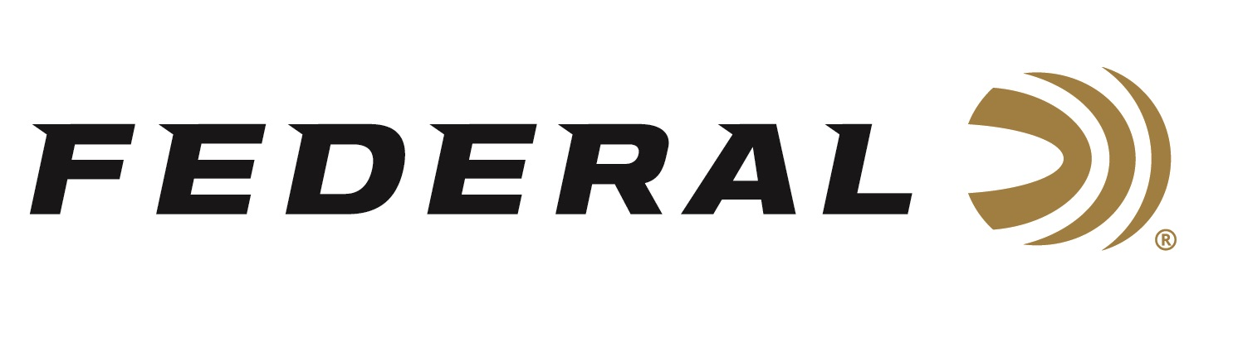

FOR IMMEDIATE RELEASE

Federal Ammunition Awarded U.S. Navy Contract for Mk316

ANOKA, Minnesota – January 16, 2024 – The U.S. Navy has selected Federal Ammunition as a contract awardee for 7.62x51mm rifle ammunition.

“Federal continues to position itself as a trusted supplier for the U.S. Military and Special Operations,” said Peter Gillette, Federal’s Director of International LE & Military Sales. “We are excited for this contract win. It validates the quality of our products, thoroughness of our testing procedures, and dedication to hard work from our American factory workers.”

The cartridge selected during the two-year contract term is the Mk316 Mod 0, 7.62x51mm, 175-grain precision match rifle load. The ordering period is for a total of two years. The ammunition will be produced by Federal at the Anoka, Minnesota facility.

“In general, our match ammunition has a legendary reputation for extreme accuracy, shot after shot, lot to lot. It is trusted time-and-time-again by police and military marksmen,” continued Gillette. “MK316 Mod 0 fits in perfectly with Federal’s history of producing extremely accurate ammunition held to tight tolerances required by strict U.S. Military specifications.”

Federal ammunition can be found nationwide and online. For more information on all products from Federal, visit www.federalpremium.com.

Press Release Contact: JJ Reich
Senior Manager – Press Relations
E-mail: VistaPressroom@VistaOutdoor.com

About Federal Ammunition
Federal, headquartered in Anoka, MN, is a brand of Vista Outdoor Inc., an outdoor sports and recreation company. From humble beginnings nestled among the lakes and woods of Minnesota, Federal Ammunition has evolved into one of the world's largest producers of sporting ammunition. Beginning in 1922, founding president, Charles L. Horn, paved the way for our success. Today, Federal carries on Horn's vision for quality products and service with the next generation of outdoorsmen and women. We maintain our position as experts in the science of ammunition production. Every day we manufacture products to enhance our customers' shooting experience while partnering with the conservation organizations that protect and support our outdoor heritage. We offer thousands of options in our Federal Premium and Federal® lines-it's what makes us the most complete ammunition company in the business and provides our customers with a choice no matter their pursuit.

