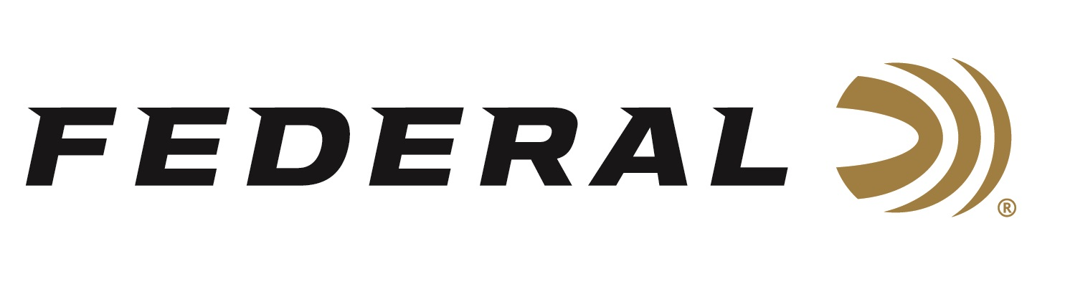
FOR IMMEDIATE RELEASE

Champion Sporting Clays Shooter and Olympian Derrick Mein Wins Federal Ammunition’s HOA Cup 2023

ANOKA, Minnesota – June 20, 2023 – Federal Ammunition sponsored shooter Derrick Mein won the Federal HOA Cup 2023 hosted by Game Unlimited Hunting Club and Sporting Clays in Hudson, Wisconsin, held June 16-18. The event grew to more than two hundred shooters in just its second year. Federal was the title sponsor for the 450-target event which included a 200-target Main Event, 150-target FITASC, 50-target 5-Stand and 50-target Super Sport.

Mein won 1st Place in the High Overall scoring. He won the Main Event and the FITASC event. He also took 2nd in 5-Stand and 4th in Super Sport. Team Federal’s Gregg Wolf also had an impressive performance. Wolf won 1st Place in 5-Stand.

“Mein and Wolf are true competitors and champions,” said Federal’s Vice President of Marketing Jason Nash. “It’s incredible to see the best shooters perform so well on tough targets. HOA is their choice of ammo, and this event highlighted its winning capabilities. We congratulate Team Federal on these accomplishments and look forward to seeing more successes at upcoming matches.”

Engineered for the most elite trap, skeet, and sporting clays shooters, Federal Premium High Over All (HOA) High Over All | Federal Premium leaves a trail of shattered targets in its wake and more reloads per shell. It’s hard, high-antimony lead payload and exclusive one-piece Podium wad produce the most consistent patterns, while the solid brass head and tapered, one-piece hull make reloading easier than ever. It's the ultimate competition load for the world's best shooters.

Federal ammunition can be found at dealers nationwide. For more information on all products from Federal or to shop online, visit www.federalpremium.com.

Pictured: Derrick Mein (Right) with Pete Melloy, General Manager of Game Unlimited (Left).

Press Release Contact: JJ Reich
Senior Manager – Press Relations
E-mail: VistaPressroom@VistaOutdoor.com

About Federal Ammunition
Federal, headquartered in Anoka, MN, is a brand of Vista Outdoor Inc., an outdoor sports and recreation company. From humble beginnings nestled among the lakes and woods of Minnesota, Federal Ammunition has evolved into one of the world's largest producers of sporting ammunition. Beginning in 1922, founding president, Charles L. Horn, paved the way for our success. Today, Federal carries on Horn's vision for quality products and service with the next generation of outdoorsmen and women. We maintain our position as experts in the science of ammunition production. Every day we manufacture products to enhance our customers' shooting experience while partnering with the conservation organizations that protect and support our outdoor heritage. We offer thousands of options in our Federal Premium and Federal® lines-it's what makes us the most complete ammunition company in the business and provides our customers with a choice no matter their pursuit.

