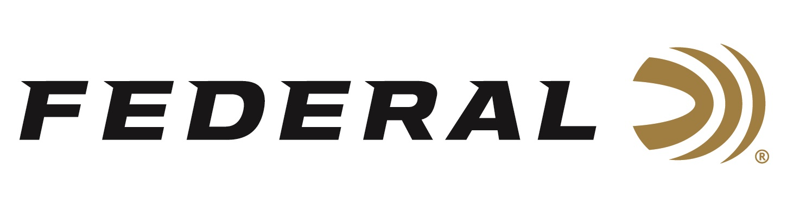

FOR IMMEDIATE RELEASE

Federal Ammunition Sponsored Shooter Derrick Mein Wins Gold at the 2023 Shotgun National Championships

ANOKA, Minnesota – May 30, 2023 – Federal Ammunition congratulates sponsored shooter Derrick Mein for becoming the 2023 Men's Trap National Champion at the Shotgun National Championships held in Hillsdale, Michigan, May 25-28, 2023. Mein, a member of USA Shooting's Shotgun National Team, was awarded a gold medal after achieving the top score at the match.

“This win means a lot to me since it brings me one step closer to making the Olympic Team for Paris 2024. Anytime you can win a national championship it is a big achievement, but I feel very blessed to stand at the top for three years in a row,” said Mein. “The U.S.A. has some of the absolute best trap shooters in the world, and to beat them you must be on top of your game. I knew I could count on my Federal ammunition to get the job done.”

While Mein has not yet earned an Olympic berth on Team U.S.A, he has been riding a wave of momentum coming into the first part of the qualifying process. “My expectations were high coming into our national championship, especially coming off a World Championship in February and earning the all-important Olympic Quota place,” continued Mein. “I felt like I could manage competing against some of the best in the world in tough conditions to bring home the victory.”

Federal is the number one choice for shotgun shells and manufactures product in America for all competitive and recreational disciplines. See the full lineup, including the latest High Over All, at www.federalpremium.com.

Federal ammunition can be found at dealers nationwide. For more information on all products from Federal or to shop online, visit www.federalpremium.com.

Photo: Derrick Mein (1st place) pictured with Seth Inman (2nd) and Logan Lucas (3rd).

Press Release Contact: JJ Reich
Senior Manager – Press Relations
E-mail: VistaPressroom@VistaOutdoor.com

About Federal Ammunition
Federal, headquartered in Anoka, MN, is a brand of Vista Outdoor Inc., an outdoor sports and recreation company. From humble beginnings nestled among the lakes and woods of Minnesota, Federal Ammunition has evolved into one of the world's largest producers of sporting ammunition. Beginning in 1922, founding president, Charles L. Horn, paved the way for our success. Today, Federal carries on Horn's vision for quality products and service with the next generation of outdoorsmen and women. We maintain our position as experts in the science of ammunition production. Every day we manufacture products to enhance our customers' shooting experience while partnering with the conservation organizations that protect and support our outdoor heritage. We offer thousands of options in our Federal Premium and Federal® lines-it's what makes us the most complete ammunition company in the business and provides our customers with a choice no matter their pursuit.

