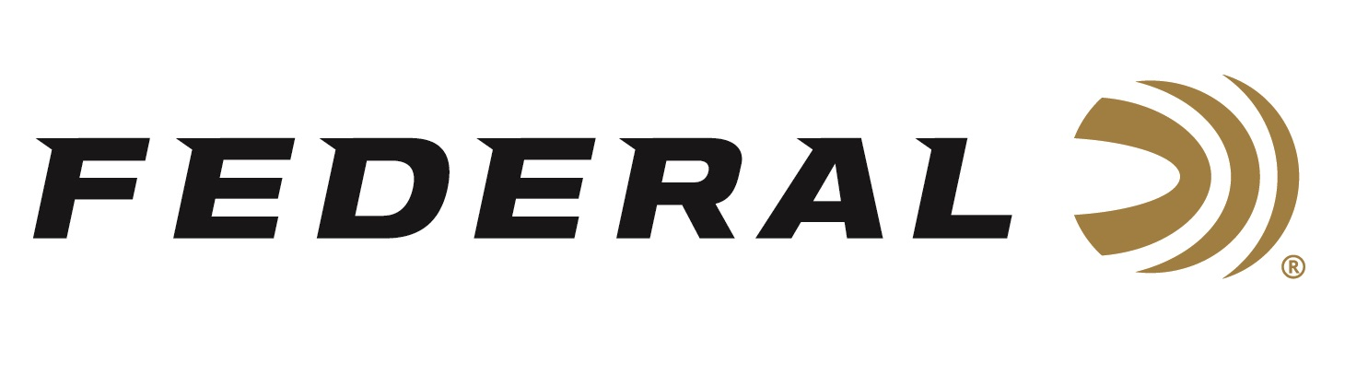

FOR IMMEDIATE RELEASE

Ready for the Holidays: New Federal Merchandise

ANOKA, Minnesota – November 27, 2023 – Demanded by hunters and shooters across the country, Federal Ammunition has added more options of high-quality branded gear for sale direct to consumers, alongside the company’s ammunition products. The new merchandise includes men’s and women’s apparel and much more.

“As we come closer to the holidays, we wanted to provide a range of items which could suit friends and family, and offer them a special present from Federal Ammunition,” said Federal's Director of E-Commerce Melissa Bang. “Our ammunition has made a lasting connection with Federal fans who want to make our brand part of their everyday lifestyle. Now, consumers can show off the Shockwave like never before with a full new line of Federal-branded products.”

Product Highlights for November 2023 include:

Federal More X3 T-Shirt
Made from premium, ultra-comfortable fabric, this T-shirt ensures you're not only stylish but also comfortable, whether you're at the range, a competition, or simply embracing the clay shooting lifestyle.

Federal S.O.F.L. Hoodie
This Moss Green Hoodie from the Federal Brand is the perfect choice for those looking for a soft and classic look. Featuring a simple classic logo and made of a soft fabric blend, this hoodie is sure to keep you warm and comfortable all day.

Federal Side by Blue/Gold
Hit the range with this new Federal logo hat. It features a denim front, gold mesh back and embroidered logo. The adjustable hat is made from 47% cotton and 53% polyester.

With new items added frequently alongside exciting sales and promotions, customers are encouraged to check regularly to see what’s new.

For more information on all products from Federal or to shop online, visit www.federalpremium.com.

Press Release Contact: JJ Reich
Senior Manager – Press Relations
E-mail: VistaPressroom@VistaOutdoor.com

About Federal Ammunition
Federal, headquartered in Anoka, MN, is a brand of Vista Outdoor Inc., an outdoor sports and recreation company. From humble beginnings nestled among the lakes and woods of Minnesota, Federal Ammunition has evolved into one of the world's largest producers of sporting ammunition. Beginning in 1922, founding president, Charles L. Horn, paved the way for our success. Today, Federal carries on Horn's vision for quality products and service with the next generation of outdoorsmen and women. We maintain our position as experts in the science of ammunition production. Every day we manufacture products to enhance our customers' shooting experience while partnering with the conservation organizations that protect and support our outdoor heritage. We offer thousands of options in our Federal Premium and Federal® lines-it's what makes us the most complete ammunition company in the business and provides our customers with a choice no matter their pursuit.

