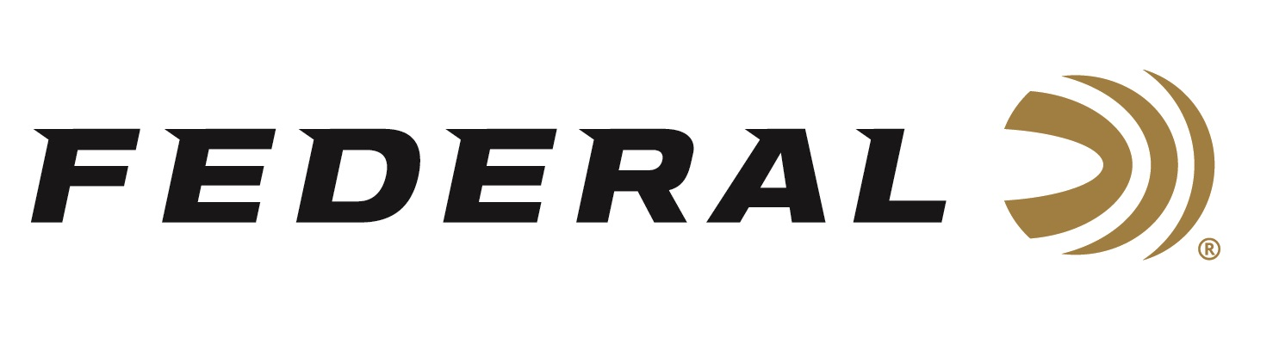

FOR IMMEDIATE RELEASE

Federal Ammunition is the Official Presenting Sponsor of the 2023 Delta Waterfowl Expo

ANOKA, Minnesota – July 26, 2023 – Federal Ammunition joins the 2023 Delta Waterfowl Duck Hunters Expo as the Presenting Sponsor. The event will be held July 28-30, 2023 in downtown Little Rock, Arkansas. Visitors to the Expo can stop by the Federal booth No. 233 to see the latest and greatest products from Federal.

“Federal is proud to be the presenting sponsor of this annual event for a second time,” said Jon Zinnel, Federal’s Senior Manager of Conservation. “Duck hunters from all over the country flock to Arkansas—which is considered the ‘Duck Hunting Capital of the World’—to check out the newest products and celebrate the hunt. Seeing thousands of our enthusiastic customers under one roof to talk waterfowl hunting is a dream for us. Hearing their stories of success in the field is what drives us to continue to produce the highest quality American-made ammunition.”

The 2023 Delta Waterfowl Duck Hunting Expo will bring waterfowl hunters together from across the United States and beyond. Attendees can check out the latest waterfowl hunting gear, watch seminars from industry experts, participate in calling contests, raffles and more. Support for the 2023 Delta Waterfowl Duck Hunting Expo will further help Delta Waterfowl in their mission to raise more ducks through intensive management programs and strong conservation efforts.

“The Delta Waterfowl logo is displayed on boxes of our Federal Speed-Shok loads,” continued Zinnel. “This is a fantastic opportunity for us to share the Delta Waterfowl story to our customers as they work to put more ducks over decoys. We are certainly proud of this collaboration.”

Waterfowl hunters look to Federal’s Speed-Shok Waterfowl loads for proven performance in the duck blind while supporting the mission of Delta Waterfowl. Available in 12- and 20-gauge varieties with velocities up to 1,550 feet-per-second, Speed-Shok combines optimal velocities with down range performance on ducks and geese.

For more information on all products from Federal or to shop online, visit www.federalpremium.com.

Press Release Contact: JJ Reich
Senior Manager – Press Relations
E-mail: VistaPressroom@VistaOutdoor.com

About Federal Ammunition
Federal, headquartered in Anoka, MN, is a brand of Vista Outdoor Inc., an outdoor sports and recreation company. From humble beginnings nestled among the lakes and woods of Minnesota, Federal Ammunition has evolved into one of the world's largest producers of sporting ammunition. Beginning in 1922, founding president, Charles L. Horn, paved the way for our success. Today, Federal carries on Horn's vision for quality products and service with the next generation of outdoorsmen and women. We maintain our position as experts in the science of ammunition production. Every day we manufacture products to enhance our customers' shooting experience while partnering with the conservation organizations that protect and support our outdoor heritage. We offer thousands of options in our Federal Premium and Federal® lines-it's what makes us the most complete ammunition company in the business and provides our customers with a choice no matter their pursuit.

