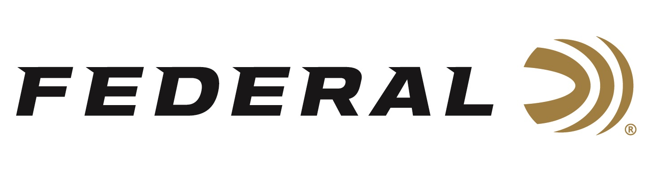

FOR IMMEDIATE RELEASE

Federal Continues Longtime Support as a Gold Level Sponsor of the
Mule Deer Foundation

ANOKA, Minnesota – December 11, 2023 – Federal Ammunition is proud to continue its longtime support of the Mule Deer Foundation (MDF) as the organization continues to stand strong for the western hunters, healthy habitat, and robust animal populations. This includes committing as a Gold Level Sponsor for the organization in 2024.

“As MDF moves forward in its 35th year ensuring the conservation of mule deer, black-tailed deer and their habitat, Federal is excited continue its support,” said Jon Zinnel, Federal’s Senior Manager of Conservation. “MDF has a strong hold when it comes to western wildlife management, conservation policy, and public access. The organization supports many conservation efforts such as tree plantings, fence removals to create more wildlife friendly fencing, fire habitat rehabilitation work, and much more.”

The Mule Deer Foundation is dedicated to restoring, improving, and protecting mule deer and black-tailed deer and their habitat, with a focus on science and program efficiency. They are committed to sustaining western deer populations by ensuring quality habitat in the areas deer need on a daily, seasonal, and yearly basis. Learn more at: www.muledeer.org.

“Corporate partnerships, like the Gold Level Sponsorship of Federal allows the organization to drive more money towards habitat work on the ground. This work supports mule deer and all western species big and small,” said Seth Reed, MDF’s Corporate Partnership Manager. “More habitats equate to healthier deer herds and provides the deer hunters better opportunities all across the western landscape.”

Federal Premium Terminal Ascent rifle ammunition is popular with big-game hunters targeting mule deer. Its bonded construction penetrates deep on close targets, while the patented Slipstream polymer tip initiates expansion at velocities 200 fps lower than comparable designs for long-range targets. The bullet’s long, sleek profile offers an extremely high ballistic coefficient, and its AccuChannel groove technology improves accuracy and minimizes drag. It’s available in a full selection of all-range hunting cartridges.

For more information on all products from Federal or to shop online, visit www.federalpremium.com.

Press Release Contact: JJ Reich
Senior Manager – Press Relations
E-mail: VistaPressroom@VistaOutdoor.com

About Federal Ammunition
Federal, headquartered in Anoka, MN, is a brand of Vista Outdoor Inc., an outdoor sports and recreation company. From humble beginnings nestled among the lakes and woods of Minnesota, Federal Ammunition has evolved into one of the world's largest producers of sporting ammunition. Beginning in 1922, founding president, Charles L. Horn, paved the way for our success. Today, Federal carries on Horn's vision for quality products and service with the next generation of outdoorsmen and women. We maintain our position as experts in the science of ammunition production. Every day we manufacture products to enhance our customers' shooting experience while partnering with the conservation organizations that protect and support our outdoor heritage. We offer thousands of options in our Federal Premium and Federal® lines-it's what makes us the most complete ammunition company in the business and provides our customers with a choice no matter their pursuit.

