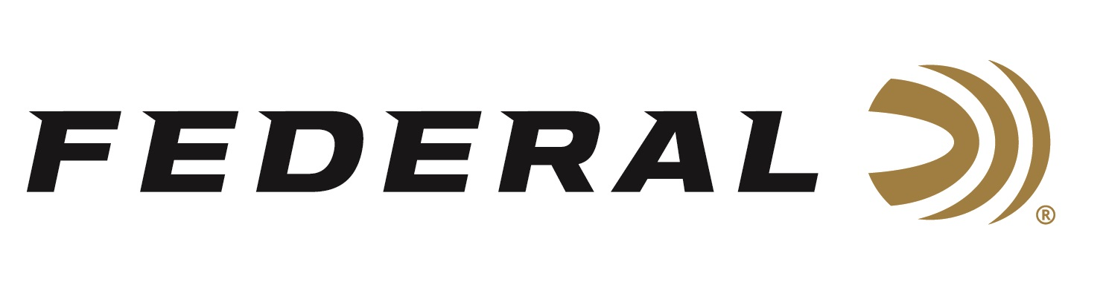

FOR IMMEDIATE RELEASE

Federal is the Official Ammunition Sponsor for
“The Habitat Organization”

ANOKA, Minnesota – November 13, 2023 – Federal Ammunition renewed its national sponsorship of Pheasants Forever and Quail Forever earlier this year which included its title as the Official Ammunition Sponsor of The Habitat Organization. The renewal continues a partnership that has existed since the mid-1980s between the world’s leading ammunition manufacturer and North America’s foremost upland habitat conservation group.

“Many upland seasons are now in full swing across the country and it’s evident the work that Pheasants Forever and Quail Forever volunteers have done is paying off,” said Jon Zinnel, Federal’s Senior Manager of Conservation. “Federal is proud of the relationship we have and the ability to see the outcomes of such strong conservation efforts that the organizations put forth across the country.”

Included in its sponsorship, Federal Ammunition has an on-box royalty program that donates a portion of proceeds from the popular Prairie Storm and Upland High Velocity shotshell ammunition lines to habitat conservation projects nationwide, and more. Federal will also be the presenting sponsor at the upcoming National Pheasant Fest and Quail Classic March 1-3, 2024 at the Denny Sandford Premier Center in Sioux Falls, South Dakota.

“The Federal brand speaks directly to the mission work accomplished by our chapters, members, and partners on a daily basis,” said Chris Kalis, Vice President of Corporate Partnerships for Pheasants Forever and Quail Forever. “As a company who covets conservation of wild things and wild places, we’re proud to call them part of the Pheasants Forever and Quail Forever family.”

Federal Premium Prairie Storm shotshells are popular with upland hunters targeting pheasants. These loads use the rear-opening FLITECONTROL FLEX wad and a mixed payload of standard pellets and FLITESTOPPER lead or steel to produce full, consistent patterns through any upland choke. It’s excellent retained velocity and energy mean increased lethality and fewer lost birds.

For more information on all products from Federal or to shop online, visit www.federalpremium.com.
Press Release Contact: JJ Reich
Senior Manager – Press Relations
E-mail: VistaPressroom@VistaOutdoor.com

About Federal Ammunition
Federal, headquartered in Anoka, MN, is a brand of Vista Outdoor Inc., an outdoor sports and recreation company. From humble beginnings nestled among the lakes and woods of Minnesota, Federal Ammunition has evolved into one of the world's largest producers of sporting ammunition. Beginning in 1922, founding president, Charles L. Horn, paved the way for our success. Today, Federal carries on Horn's vision for quality products and service with the next generation of outdoorsmen and women. We maintain our position as experts in the science of ammunition production. Every day we manufacture products to enhance our customers' shooting experience while partnering with the conservation organizations that protect and support our outdoor heritage. We offer thousands of options in our Federal Premium and Federal® lines-it's what makes us the most complete ammunition company in the business and provides our customers with a choice no matter their pursuit.

