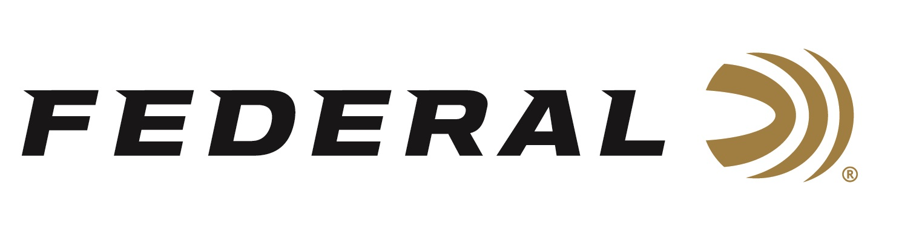

FOR IMMEDIATE RELEASE

Federal Ammunition: Proud National Partner of the Ruffed Grouse Society and the American Woodcock Society

ANOKA, Minnesota – November 28, 2023 – Federal Ammunition continues its longtime partnerships with the Ruffed Grouse Society (RGS) and the American Woodcock Society (AWS) to help these organizations leverage their conservation work across the regions where these species flourish.

“Hunting seasons for ruffed grouse and woodcock have been outstanding this year. Many of our customers have reported remarkable success and fun,” said Jon Zinnel, Federal’s Senior Manager of Conservation. “These great organizations are focused on landscape-scale impact to woodland habitats where these gamebirds thrive. Their efforts and strategies are not only good for upland birds but for all woodland wildlife large and small.”

The RGS and AWS unite conservationists in places such as Minnesota, New York, Pennsylvania, and many states east of the Mississippi river. The vision of these organizations is to create landscapes of diverse, functioning forest ecosystems that provide homes for wildlife and opportunities for people to experience them. Learn more at: www.ruffedgrousesociety.org.

“We so appreciate Federal’s support of RGS & AWS forest habitat improvement efforts,” said Ben Jones, Chief Executive Officer of RGS and AWS. “There is much conservation work to do. We look forward to expanding this partnership into the future for even greater benefit for our woods and wildlife.”

Federal Heavy Field Game Loads are popular with grouse and woodcock hunters. They are carefully crafted and packed with features that provide reliable, effective performance on a variety of upland game. These features include: High-quality round shot is formulated for optimum hardness, improving pattern efficiency; Brass-plated steel head and one-piece wad maximize payloads; Select, high-quality propellant and non-corrosive primer deliver efficient, reliable ignition; Available in 12- 20-, and 28-gauge options.

For more information on all products from Federal or to shop online, visit www.federalpremium.com.

Press Release Contact: JJ Reich
Senior Manager – Press Relations
E-mail: VistaPressroom@VistaOutdoor.com

About Federal Ammunition
Federal, headquartered in Anoka, MN, is a brand of Vista Outdoor Inc., an outdoor sports and recreation company. From humble beginnings nestled among the lakes and woods of Minnesota, Federal Ammunition has evolved into one of the world's largest producers of sporting ammunition. Beginning in 1922, founding president, Charles L. Horn, paved the way for our success. Today, Federal carries on Horn's vision for quality products and service with the next generation of outdoorsmen and women. We maintain our position as experts in the science of ammunition production. Every day we manufacture products to enhance our customers' shooting experience while partnering with the conservation organizations that protect and support our outdoor heritage. We offer thousands of options in our Federal Premium and Federal® lines-it's what makes us the most complete ammunition company in the business and provides our customers with a choice no matter their pursuit.

