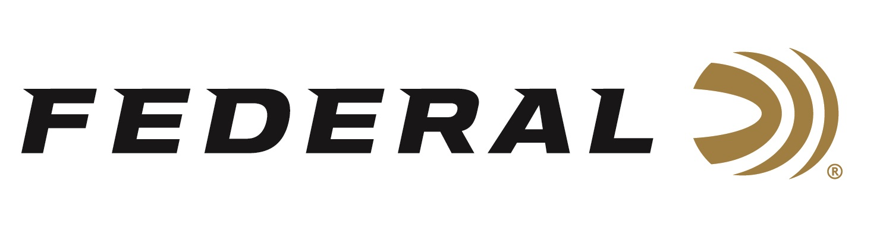

FOR IMMEDIATE RELEASE

Federal’s FireStick Blazes Its Way Into More Muzzleloader Seasons

ANOKA, Minnesota – November 15, 2023 – Federal Ammunition’s FireStick muzzleloader ignition system has now been approved for use during the muzzleloader specific seasons in 25 states, including Minnesota, Kansas, Pennsylvania, and more.
Additionally, several more state approvals are anticipated in 2024.

“As the muzzleloader seasons approach, the use of this new revolutionary FireStick system is blazing the way for new hunters to try muzzleloading,” said Federal Ammunition Muzzleloader Product Director Dan Compton. “It not only allows for a less intimidating experience for the newcomers, it also has helped to reactivate former muzzleloader hunters to get back into the sport. Many of these hunters had gotten frustrated with the complexities, cleaning hassles, and inconsistencies of less modern muzzleloading rifles. All those frustrations are solved with Federal’s FireStick system.”

Federal engineers opened a whole new chapter in muzzleloading technology with the FireStick launch several years ago. This all-new ignition system charges from the breech, yet the projectile is loaded from the muzzle. The FireStick powder capsule is impervious to moisture and built to the same tight tolerances as Federal Premium Ammunition. It is a quick, simple, and safe system for hunters of all experience levels.

“The FireStick system is now being utilized in rifles manufactured by two of the industry leaders in muzzleloading; Traditions, and CVA,” continued Compton. “The NitroFire rifle from Traditions and the new Crossfire rifle from CVA both offer hunters different options to fit their preferences.”

There’s never been a muzzleloading system like FireStick. Learn all the details that set FireStick apart, giving hunters convenient, safe, and consistent performance.
Learn more at: www.federalpremium.com/muzzleloading/firestick/.

For more information on all products from Federal or to shop online, visit www.federalpremium.com.

Press Release Contact: JJ Reich
Senior Manager – Press Relations
E-mail: VistaPressroom@VistaOutdoor.com

About Federal Ammunition
Federal, headquartered in Anoka, MN, is a brand of Vista Outdoor Inc., an outdoor sports and recreation company. From humble beginnings nestled among the lakes and woods of Minnesota, Federal Ammunition has evolved into one of the world's largest producers of sporting ammunition. Beginning in 1922, founding president, Charles L. Horn, paved the way for our success. Today, Federal carries on Horn's vision for quality products and service with the next generation of outdoorsmen and women. We maintain our position as experts in the science of ammunition production. Every day we manufacture products to enhance our customers' shooting experience while partnering with the conservation organizations that protect and support our outdoor heritage. We offer thousands of options in our Federal Premium and Federal® lines-it's what makes us the most complete ammunition company in the business and provides our customers with a choice no matter their pursuit.

