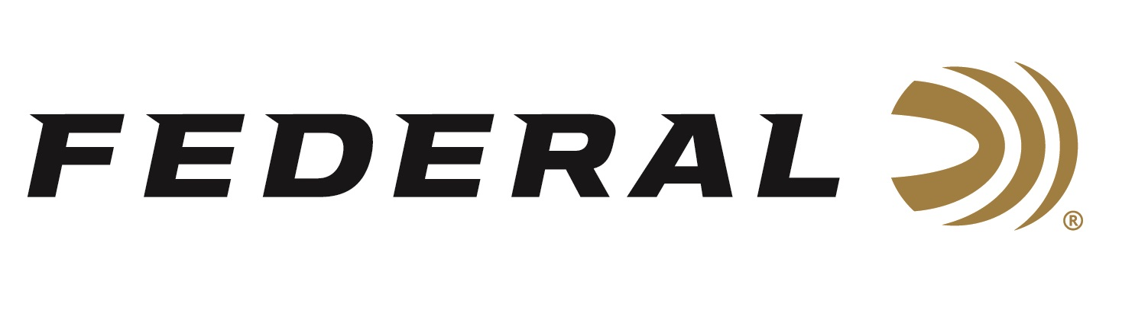

FOR IMMEDIATE RELEASE

**Federal Ammunition** **Announces Ballistic AE App Additions**

**ANOKA, Minnesota – January 5, 2023 –** Federal Ammunition has added its latest load offerings to the updated Ballistic AE app. This leading Ballistic app is available for free to download on iOS devices.

“We’re excited to work on the Ballistic AE app to improve this technology and offer shooters another tool to increase their odds of success in the field,” said Federal Marketing Director Brian Anderson. “Getting our latest loads incorporated in the app—headlined by our popular and proven Terminal Ascent—provides our customers with more data to advance their shooting skills.”

Powered by the trusted JBM Ballistics computer, Ballistic AE is a definitive calculator for iOS devices. This app calculates trajectory, windage, velocity, energy, lead, and bullet flight time for any range. It compensates for atmospheric conditions such as temperature, barometric pressure, humidity, altitude and more.

The app contains a deep library of projectiles and factory loads, now featuring the most versatile big game loads—Federal’s Terminal Ascent. It also contains a mil-dot and MOA rangefinder, GPS and atmosphere awareness, full-size charts, a precision target log and far more.

Download the app today and look for continued updates throughout the year.

To learn more about Federal’s app, visit: [Our Apps (federalpremium.com)](https://www.federalpremium.com/this-is-federal/get-the-app/).

For more information on all products from Federal or to shop online, visit [www.federalpremium.com](http://www.federalpremium.com).

**Press Release Contact: JJ Reich**

Senior Manager – Press Relations

E-mail: [VistaPressroom@VistaOutdoor.com](mailto:VistaPressroom@VistaOutdoor.com)

**About Federal Ammunition**

Federal, headquartered in Anoka, MN, is a brand of Vista Outdoor Inc., an outdoor sports and recreation company. From humble beginnings nestled among the lakes and woods of Minnesota, Federal Ammunition has evolved into one of the world's largest producers of sporting ammunition. Beginning in 1922, founding president, Charles L. Horn, paved the way for our success. Today, Federal carries on Horn's vision for quality products and service with the next generation of outdoorsmen and women. We maintain our position as experts in the science of ammunition production. Every day we manufacture products to enhance our customers' shooting experience while partnering with the conservation organizations that protect and support our outdoor heritage. We offer thousands of options in our Federal Premium and Federal® lines-it's what makes us the most complete ammunition company in the business and provides our customers with a choice no matter their pursuit.