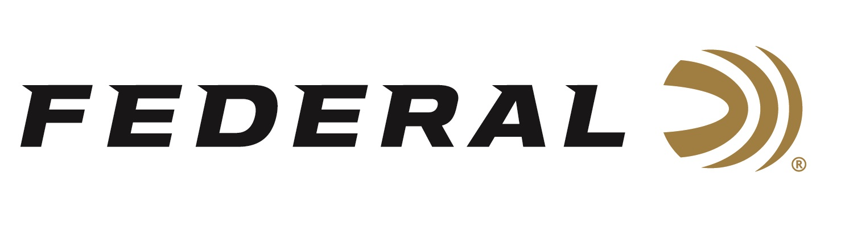

FOR IMMEDIATE RELEASE

Federal Will Announce New Handgun Ammunition at the 2023 SHOT Show

ANOKA, Minnesota – January 6, 2023 – Federal Ammunition is proud to announce new handgun ammunition options for 2023. Several all-new products and line extensions will be showcased and on display at the 2023 SHOT Show (Booth No. 11838), January 17–20 at the Venetian Expo and Caesars Forum in Las Vegas, Nevada. These new additions include new offerings in Federal’s Train + Protect, Punch, and Gold Medal product lines.

Federal engineers designed both Punch ammunition and the new 30 Super Carry cartridge from the ground up for self-defense, and the two have come together in a load that’s far easier to shoot effectively. The blending of the two technologies gives shooters an extremely effective option for real-world defense.

Compete at the highest level with loads designed specifically for the action shooting sports. New Gold Medal Action Pistol—available in 9mm Luger and 40 S&W—offers even better accuracy and consistency than original Gold Medal, and it’s loaded to power-factor requirements. The fully encapsulated FMJ bullet and Catalyst lead-free primer deliver cleaner shooting.

Federal has made it easier than ever to honor your birthright to bear arms with a new Train + Protect load in 10mm Auto. The full-power offering features a VHP bullet to deliver both precise, practical performance at the range, and instant, reliable expansion on impact.

Attendees of the 2023 SHOT Show are encouraged to stop by Booth No. 11838 for a first-hand look at these new products and more. Information about the new products and line extensions can soon be found on Federal’s brand website.

For more information on all products from Federal or to shop online, visit www.federalpremium.com.

Press Release Contact: JJ Reich
Senior Manager – Press Relations
E-mail: VistaPressroom@VistaOutdoor.com
About Federal Ammunition
Federal, headquartered in Anoka, MN, is a brand of Vista Outdoor Inc., an outdoor sports and recreation company. From humble beginnings nestled among the lakes and woods of Minnesota, Federal Ammunition has evolved into one of the world's largest producers of sporting ammunition. Beginning in 1922, founding president, Charles L. Horn, paved the way for our success. Today, Federal carries on Horn's vision for quality products and service with the next generation of outdoorsmen and women. We maintain our position as experts in the science of ammunition production. Every day we manufacture products to enhance our customers' shooting experience while partnering with the conservation organizations that protect and support our outdoor heritage. We offer thousands of options in our Federal Premium and Federal® lines-it's what makes us the most complete ammunition company in the business and provides our customers with a choice no matter their pursuit.

