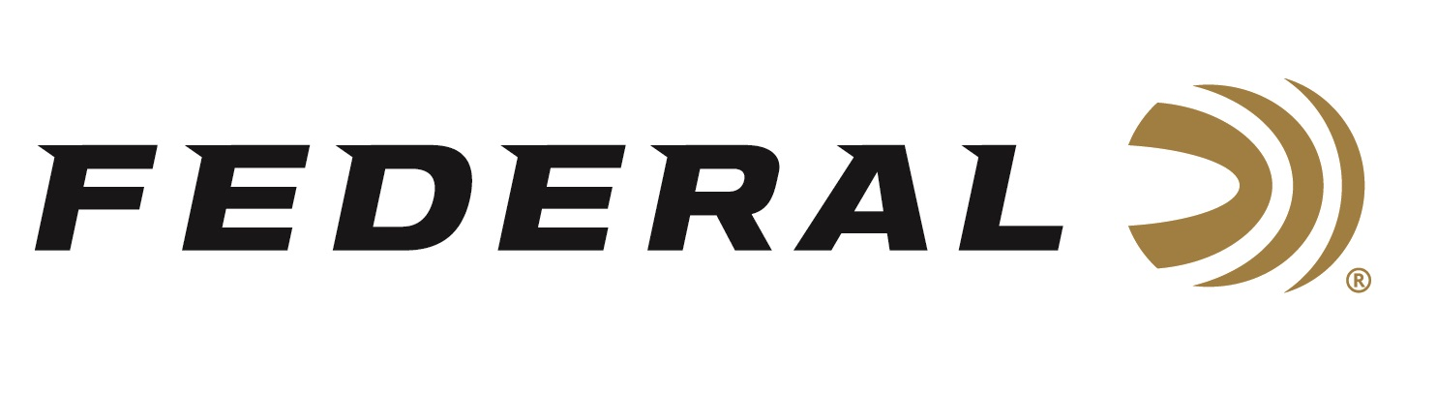

FOR IMMEDIATE RELEASE

Federal Will Announce New Centerfire Rifle Ammunition at the 2023 SHOT Show

ANOKA, Minnesota – January 9, 2023 – Federal Ammunition is proud to announce new centerfire rifle ammunition options for 2023. Several all-new products will be showcased and on display at the 2023 SHOT Show (Booth No. 11838), January 17–20 at the Venetian Expo and Caesars Forum in Las Vegas, Nevada. These new additions include new Gold Medal CenterStrike and ELD-X rifle loads, plus more.

Designed for competition and serious long-range target shooters, Gold Medal CenterStrike’s proprietary open tip match bullet has a sleek profile and is held to extremely tight specifications for ultimate long-range accuracy and consistency. Its available in 308 Win., 6.5 Creedmoor and 223 Rem.

The ELD-X hunting bullet has a reputation for being match-accurate and hard-hitting. It touts a high ballistic coefficient and a design that provides effective expansion at a wide range of velocities. Federal is now loading this well-known bullet in nine centerfire cartridge options from 243 Win. to 300 Win. Magnum; using Federal’s own factory-made components and strict manufacturing processes.

Attendees of the 2023 SHOT Show are encouraged to stop by Booth No. 11838 for a first-hand look at these new products and more. Information about the new products and line extensions can soon be found on Federal’s brand website.

For more information on all products from Federal or to shop online, visit www.federalpremium.com.

Press Release Contact: JJ Reich
Senior Manager – Press Relations
E-mail: VistaPressroom@VistaOutdoor.com

About Federal Ammunition
Federal, headquartered in Anoka, MN, is a brand of Vista Outdoor Inc., an outdoor sports and recreation company. From humble beginnings nestled among the lakes and woods of Minnesota, Federal Ammunition has evolved into one of the world's largest producers of sporting ammunition. Beginning in 1922, founding president, Charles L. Horn, paved the way for our success. Today, Federal carries on Horn's vision for quality products and service with the next generation of outdoorsmen and women. We maintain our position as experts in the science of ammunition production. Every day we manufacture products to enhance our customers' shooting experience while partnering with the conservation organizations that protect and support our outdoor heritage. We offer thousands of options in our Federal Premium and Federal® lines-it's what makes us the most complete ammunition company in the business and provides our customers with a choice no matter their pursuit.

