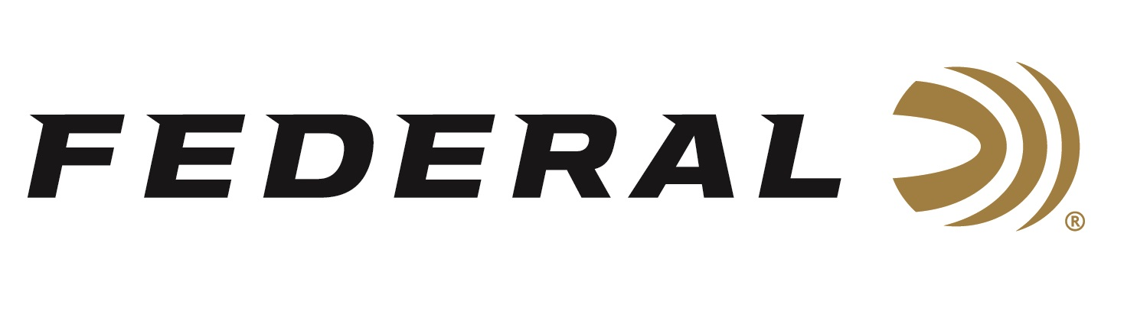

FOR IMMEDIATE RELEASE

Federal Will Announce New Shotshell Ammunition at the 2023 SHOT Show

ANOKA, Minnesota – January 10, 2023 – Federal Ammunition is proud to announce new shotshell ammunition options for 2023. Several all-new products and line extensions will be showcased and on display at the 2023 SHOT Show (Booth No. 11838), January 17–20 at the Venetian Expo and Caesars Forum in Las Vegas, Nevada. This ammunition includes new offerings in the High Over All, Black Cloud, HEVI-Bismuth, Hi-Bird, and Premium Buckshot product lines, plus more.

Premium High Over All is engineered for the most elite trap, skeet and sporting clays shooters. It’s hard, high-antimony lead payload and wad produce the most consistent patterns, while the solid brass head and hull design make reloading easier than ever. It’s the ultimate competition load for the world’s best shooters. New for 2023 are a 28-gauge and .410 bore options, and more.

More than a decade ago, Black Cloud changed the definition of performance for steel waterfowl loads. That revolution continues today with Black Cloud 28-gauge offerings that redefine the capability of sub-gauges. Like all Black Cloud loads, they use the FLITECONTROL FLEX wad to deliver better pattern density and consistency through both ported and standard waterfowl chokes.

Federal Premium HEVI-Bismuth hits both upland birds and waterfowl with the power of 9.6 g/cc density pellets. Sourced from Federal’s affiliate company, HEVI-Shot, HEVI Bismuth shot is 22 percent denser than steel, delivering more lethal energy downrange. Launched by the FLITECONTROL FLEX wad, bismuth pellets pattern consistently, and are alloyed and cast in the USA.

Hi-Bird Fiber Wad’s cellulose-based over-powder wad construction helps minimize plastic left in the field with the same great performance as the original. It’s perfect for the field or preserve hunting situations. Its available in two 12-gauge, 2 3/4-inch options.

The new Premium Buckshot 1 buck offering provides precision performance. Its payload of 16 copper-plated pellets produces tight patterns for more hits and better stopping power on predators, hogs and more. A Power-Shok 1 buck load is also new for 2023.
Attendees of the 2023 SHOT Show are encouraged to stop by Booth No. 11838 for a first-hand look at these new products and more. Information about the new products and line extensions can soon be found on Federal’s brand website.

For more information on all products from Federal or to shop online, visit www.federalpremium.com.

Press Release Contact: JJ Reich
Senior Manager – Press Relations
E-mail: VistaPressroom@VistaOutdoor.com

About Federal Ammunition
Federal, headquartered in Anoka, MN, is a brand of Vista Outdoor Inc., an outdoor sports and recreation company. From humble beginnings nestled among the lakes and woods of Minnesota, Federal Ammunition has evolved into one of the world's largest producers of sporting ammunition. Beginning in 1922, founding president, Charles L. Horn, paved the way for our success. Today, Federal carries on Horn's vision for quality products and service with the next generation of outdoorsmen and women. We maintain our position as experts in the science of ammunition production. Every day we manufacture products to enhance our customers' shooting experience while partnering with the conservation organizations that protect and support our outdoor heritage. We offer thousands of options in our Federal Premium and Federal® lines-it's what makes us the most complete ammunition company in the business and provides our customers with a choice no matter their pursuit.

