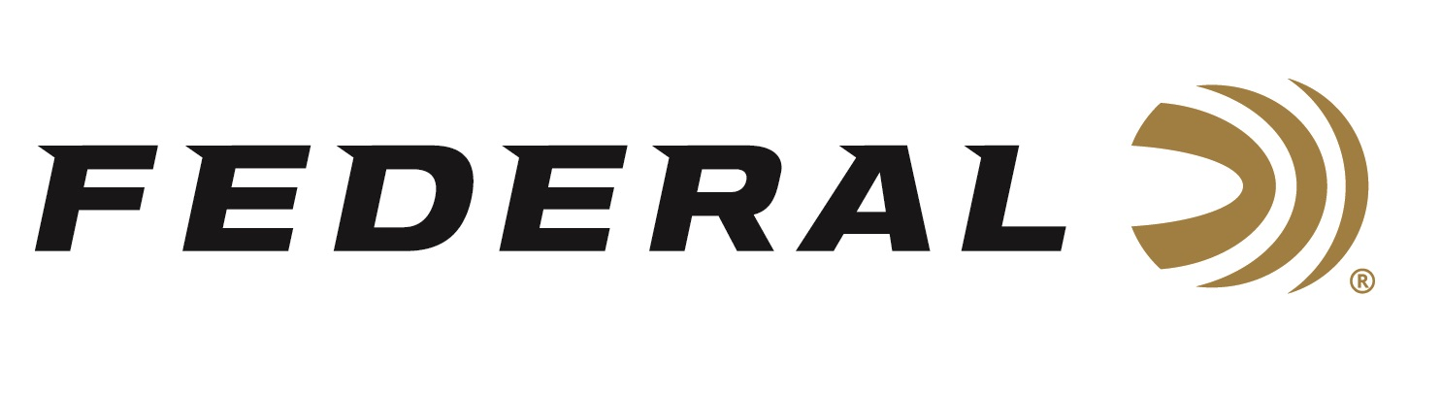
FOR IMMEDIATE RELEASE

Federal Recognized as Most Frequently Purchased Rifle Ammunition Brand in Southwick Report

ANOKA, Minnesota – March 28, 2023 – Southwick Associates’ 2022 “Hunting & Shooting Participation and Equipment Purchases Consumer Tracking Study” named Federal Ammunition as the top rifle ammunition brand in 2022. Southwick’s yearly survey compiled the feedback of over 9,000 hunters and recreational shooters.

“We are excited to see Federal Ammunition as the top choice for rifle ammunition,” said Federal Centerfire Rifle Product Director, Mike Holm. “In the rifle ammunition purchase survey, Federal accounted for the highest percentage of total boxes purchased overall. This report shows the efforts of everyone at Federal are well received by rifle shooters. Our commitment is to produce a top-quality product that hunters and shooters can rely on, and this survey proves we are succeeding in our efforts.”

Federal has enhanced its Premium line and is offering the latest calibers for hunters and competitive target shooters. Its own Terminal Ascent line has been highly successful. Terminal Ascent features bonded construction that penetrates deep on close targets, while the patented Slipstream™ polymer tip initiates expansion at velocities 200 fps lower than comparable designs. The bullet’s long, sleek profile offers an extremely high ballistic coefficient, and its AccuChannel groove technology improves accuracy and minimizes drag.

“Quality and performance continue to keep Federal rifle ammunition at the top,” said Holm. “From the production line to everyone involved in the development and creation of Federal Ammunition products, all of us at Federal take immense pride in producing a line of rifle ammunition that continues to have a stellar reputation. With all our different products and sub-brands, rifle shooters are sure to find their perfect match for performance in the field or on the bench.”

Southwick’s in-depth resources illustrate shopping behaviors, such as where consumers buy, brand preferences, and amount spent. Learn more at www.southwickassociates.com.

Federal ammunition can be found at dealers nationwide. For more information on all products from Federal or to shop online, visit www.federalpremium.com.

Press Release Contact: JJ Reich
Senior Manager – Press Relations
E-mail: VistaPressroom@VistaOutdoor.com

About Federal Ammunition
Federal, headquartered in Anoka, MN, is a brand of Vista Outdoor Inc., an outdoor sports and recreation company. From humble beginnings nestled among the lakes and woods of Minnesota, Federal Ammunition has evolved into one of the world's largest producers of sporting ammunition. Beginning in 1922, founding president, Charles L. Horn, paved the way for our success. Today, Federal carries on Horn's vision for quality products and service with the next generation of outdoorsmen and women. We maintain our position as experts in the science of ammunition production. Every day we manufacture products to enhance our customers' shooting experience while partnering with the conservation organizations that protect and support our outdoor heritage. We offer thousands of options in our Federal Premium and Federal® lines-it is what makes us the most complete ammunition company in the business and provides our customers with a choice no matter their pursuit.

