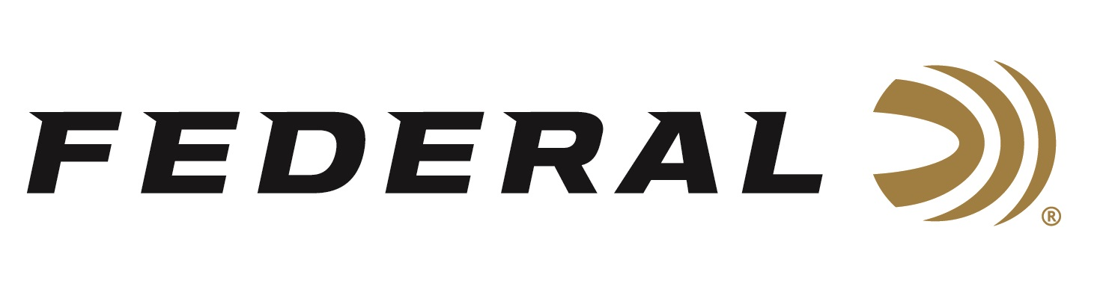

FOR IMMEDIATE RELEASE

Federal Recognized as Most Frequently Purchased Shotshell Ammunition Brand in Southwick Report

ANOKA, Minnesota – March 24, 2023 – Federal Ammunition leads the category of most frequently purchased shotgun ammunition according to the Southwick Associates’ 2022 “Hunting & Shooting Participation and Equipment Purchases Consumer Tracking Study.” Southwick’s yearly survey compiled the feedback of over 9,000 hunters and recreational shooters.

“The fact that Federal shotshell ammunition leads the category for most shotgun ammo purchased is a testament to the demanding work everyone at Federal puts into creating these products,” said Dan Compton, Product Director for Federal Shotshell Ammunition. “This year’s survey showed the highest percentage of all shotshell ammo purchased was Federal. This is truly a team effort, and our company couldn’t be prouder.”

Federal has expanded its shotshell lineup in the past several years, adding a competition target lineup in High Over All, along with sub-gauge extensions for Top Gun, Black Cloud and a new Bismuth offering featuring HEVI-Bismuth. New HEVI-Bismuth shot is 22 percent denser than steel, delivering more lethal energy downrange. Launched by the FLITECONTROL FLEX wad, bismuth pellets pattern consistently, and their metallic properties make them safe in both modern and classic shotguns.

“We want to continue to have Federal Ammunition be a company that fills all of your shotgun ammunition needs,” said Compton. “For those that enjoy cold mornings in the duck blind, to busting clays, and for home defense, Federal Ammunition’s quality and trusted performance is there to meet those needs. With Federal’s wide range of product choices, shotgun hunters and shooters can easily find a product to fit their needs.”

Southwick’s in-depth resources illustrate shopping behaviors, such as where consumers buy, brand preferences, and amount spent. Learn more at www.southwickassociates.com.

Federal ammunition can be found at dealers nationwide. For more information on all products from Federal or to shop online, visit www.federalpremium.com.

Press Release Contact: JJ Reich
Senior Manager – Press Relations
E-mail: VistaPressroom@VistaOutdoor.com

About Federal Ammunition
Federal, headquartered in Anoka, MN, is a brand of Vista Outdoor Inc., an outdoor sports and recreation company. From humble beginnings nestled among the lakes and woods of Minnesota, Federal Ammunition has evolved into one of the world's largest producers of sporting ammunition. Beginning in 1922, founding president, Charles L. Horn, paved the way for our success. Today, Federal carries on Horn's vision for quality products and service with the next generation of outdoorsmen and women. We maintain our position as experts in the science of ammunition production. Every day we manufacture products to enhance our customers' shooting experience while partnering with the conservation organizations that protect and support our outdoor heritage. We offer thousands of options in our Federal Premium and Federal® lines-it is what makes us the most complete ammunition company in the business and provides our customers with a choice no matter their pursuit.

