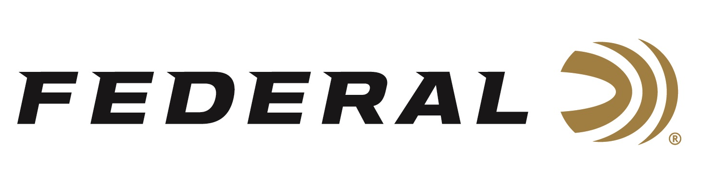

FOR IMMEDIATE RELEASE

On Target Magazine Honors Federal Premium Force X2 Shorty 00 Buckshot with Editors’ Choice Award

ANOKA, Minnesota – January 26, 2023 – On Target magazine recently recognized Force X2 Shorty Shotshell with an Editors’ Choice Award for best new shotshell ammunition for 2022, as part of the magazine’s annual awards program.

“These awards are reserved for the best-of-the-best new products which demonstrate outstanding technical achievement and/or represent an extraordinary value for the money,” said On Target Magazine Editor Ben Battles. “The concept behind Force X2 is straightforward: In a 6-pellet 00 FX2 Buck load you get 12 wound channels. And with the short size, you get more magazine capacity. It’s as simple as that. And it’s certainly deserving of this recognition.”

Federal Ammunition added the Force X2 Shorty Shotshell to the line of Premium Personal Defense Shotshells in the summer of 2022. The Force X2 Shorty is designed for use in firearms capable of cycling sub-length shotshells. This new 12-gauge 1 ¾-inch shotshell allows for higher magazine capacity with up to twice the wound channels over traditional buckshot pellets.

Force X2 Shorty packs a punch with six-pellet 00 copper plated segmenting buckshot. Each pellet is designed to split in half on impact. This allows the loads to have double the wound channels while reducing the risk of collateral damage from over penetration. Force X2 Shorty carries the same quality and performance expected by users of the standard-sized Force X2 shotshells (2 3/4-inch loads). The Force X2 Shorty design and cartridge size also delivers the benefit of manageable recoil for when repeatability is needed.

On Target is one of the leading publications in the shooting sports industry. Its staff tests and reviews guns, ammunition, and hunting products, and presents the results in a straightforward, no-nonsense format that provides all the information consumers need to make purchase decisions. The print version of On Target can be picked up free at any of the nearly 2,000 firearm and hunting product retailers nationwide that distribute the magazine.

Federal ammunition can be found at dealers nationwide. For more information on all products from Federal or to shop online, visit www.federalpremium.com.
Press Release Contact: JJ Reich
Senior Communications Manager - Ammunition
E-mail: VistaPressroom@VistaOutdoor.com

About Federal Ammunition
Federal, headquartered in Anoka, MN, is a brand of Vista Outdoor Inc., an outdoor sports and recreation company. From humble beginnings nestled among the lakes and woods of Minnesota, Federal Ammunition has evolved into one of the world's largest producers of sporting ammunition. Beginning in 1922, founding president, Charles L. Horn, paved the way for our success. Today, Federal carries on Horn's vision for quality products and service with the next generation of outdoorsmen and women. We maintain our position as experts in the science of ammunition production. Every day we manufacture products to enhance our customers' shooting experience while partnering with the conservation organizations that protect and support our outdoor heritage. We offer thousands of options in our Federal Premium and Federal® lines-it's what makes us the most complete ammunition company in the business and provides our customers with a choice no matter their pursuit.

###

