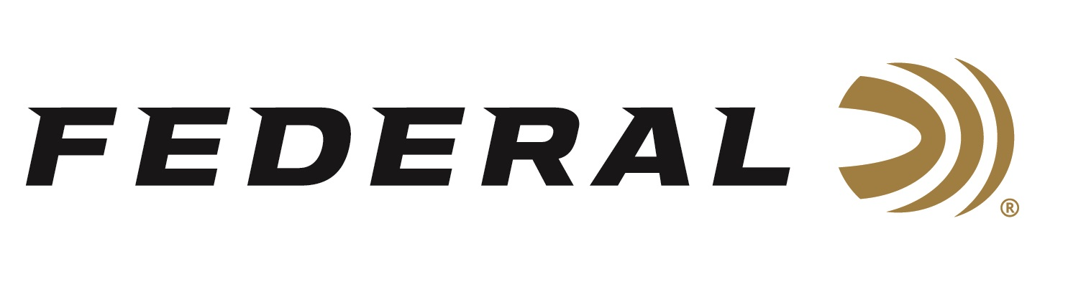

FOR IMMEDIATE RELEASE

Federal Ammunition Introduces New Gold Medal CenterStrike Match Loads

ANOKA, Minnesota – May 10, 2023 – Federal Ammunition is proud to introduce a new product line of match-grade centerfire rifle ammunition: Federal Premium Gold Medal CenterStrike. These new match-grade loads feature a proprietary open tip match design, sleek profile and extremely tight specifications for the ultimate long-range accuracy and consistency. 168-grain and 175-grain 308 Win. loads are currently shipping to dealers. 6.5 Creedmoor is anticipated to ship in the summer.

“CenterStrike features a new Open Tip Match bullet that will allow us to expand our Gold Medal product lineup with more options and is ideal for any target shooter looking for long-range accuracy and consistent performance,” said Federal Centerfire Rifle Ammunition Product Line Manager, Eric Miller. “The new CenterStike product line continues the tradition of Gold Medal standards delivering industry-leading accuracy in factory-loaded ammunition.”

Summary of features include: Precision-built OTM bullet design; High ballistic coefficient design; Held to Federal’s tightest specs for accuracy, pressure, and velocity; Gold Medal primers and brass; Specially formulated propellant; Available in 308 Win., 6.5 Creedmoor and 223 Rem; 20-round boxes; MSRP: $37.99-$48.99.

For more information on all products from Federal or to shop online, visit www.federalpremium.com.

Press Release Contact: JJ Reich
Senior Manager – Press Relations
E-mail: VistaPressroom@VistaOutdoor.com

About Federal Ammunition
Federal, headquartered in Anoka, MN, is a brand of Vista Outdoor Inc., an outdoor sports and recreation company. From humble beginnings nestled among the lakes and woods of Minnesota, Federal Ammunition has evolved into one of the world's largest producers of sporting ammunition. Beginning in 1922, founding president, Charles L. Horn, paved the way for our success. Today, Federal carries on Horn's vision for quality products and service with the next generation of outdoorsmen and women. We maintain our position as experts in the science of ammunition production. Every day we manufacture products to enhance our customers' shooting experience while partnering with the conservation organizations that protect and support our outdoor heritage. We offer thousands of options in our Federal Premium and Federal® lines-it's what makes us the most complete ammunition company in the business and provides our customers with a choice no matter their pursuit.

