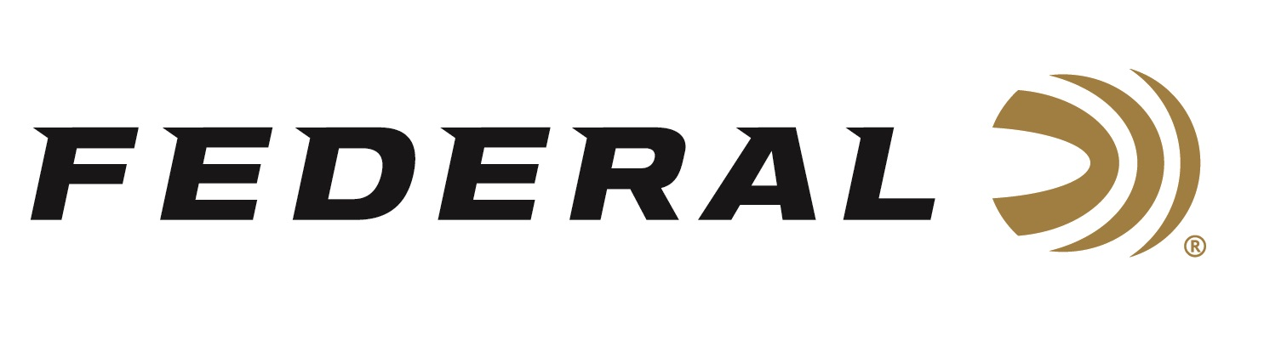

FOR IMMEDIATE RELEASE

Federal Announces Gold Medal Action Pistol Ammunition Which Meets Competition Power-Factor Requirements

ANOKA, Minnesota – October 16, 2023 – Federal Ammunition is proud to announce a new product line called Gold Medal Action Pistol; manufactured specifically for those who compete at the highest level in any action shooting sport. The new Gold Medal Action Pistol offers even better accuracy and consistency than the original Gold Medal, and it’s loaded to competition power-factor requirements. The fully encapsulated FMJ bullet and Catalyst lead-free primer delivers cleaner shooting. The all-new Gold Medal Action Pistol loads are available in 9mm Luger, 147-grain FMJ and 40 S&W, 180-grain FMJ.

Gold Medal Handgun 9mm Luger GM9AP1 | Federal Ammunition

“Gold Medal Action Pistol is specifically designed for the action shooting sports and loaded to power factor requirements with heavy, flatter-nosed bullets for more reliable knockdowns on steel targets in competition,” said Federal’s Handgun Ammunition Product Manager, Chris Laack. “We have a similar product in Syntech Action Pistol that has been extremely successful the past several years, and we are proud to now offer Gold Medal Action Pistol as well. This delivers more options to our competition-focused customers.”

Gold Medal Action Pistol is available in 50-round boxes; MSRP: 9mm for $30.99; 40 S&W for $42.99.

“With competitive handgun shooting sports evolving, Gold Medal options for Action Pistol were long overdue,” continued Laack. “These clean shooting 9mm Luger and 40 S&W loads provide the excellent accuracy and reliability Federal Gold Medal is famous for, while also offering benefits such as lead-free primers and encapsulated bullets. We are extremely proud to now offer this new product line.”

For more information on all products from Federal or to shop online, visit www.federalpremium.com.

Press Release Contact: JJ Reich
Senior Manager – Press Relations
E-mail: VistaPressroom@VistaOutdoor.com
About Federal Ammunition
Federal, headquartered in Anoka, MN, is a brand of Vista Outdoor Inc., an outdoor sports and recreation company. From humble beginnings nestled among the lakes and woods of Minnesota, Federal Ammunition has evolved into one of the world's largest producers of sporting ammunition. Beginning in 1922, founding president, Charles L. Horn, paved the way for our success. Today, Federal carries on Horn's vision for quality products and service with the next generation of outdoorsmen and women. We maintain our position as experts in the science of ammunition production. Every day we manufacture products to enhance our customers' shooting experience while partnering with the conservation organizations that protect and support our outdoor heritage. We offer thousands of options in our Federal Premium and Federal® lines-it's what makes us the most complete ammunition company in the business and provides our customers with a choice no matter their pursuit.

