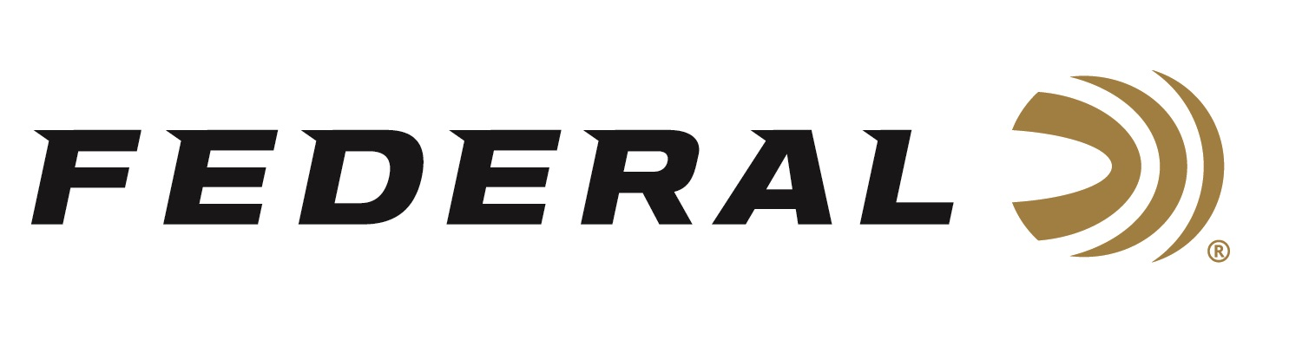
FOR IMMEDIATE RELEASE

Federal Adds Fifteen Sub-Gauge Options to Its Popular High Over All Target Load Lineup

ANOKA, Minnesota – April 5, 2024 – Federal Ammunition adds 15 new sub-gauge product options to its popular Federal Premium High Over All (HOA) product lineup. Engineered for the most elite trap, skeet and sporting clays shooters, HOA leaves a trail of shattered targets in its wake and more reloads per shell. Its hard, high-antimony lead payload and wads produce the most consistent patterns, while the solid brass head and hull design make reloading easier than ever. Now available in a complete lineup of loads, including new 20-gauge, 28-gauge, and .410 bore options.

High Over All | Federal Premium

“When first developing High Over All in 2021, a long list of 12-guage loads were an obvious first choice to roll out,” said Federal Shotshell Product Director Dan Compton. “The product line became an almost instant success in 12-gauge, and we are now excited to expand our HOA product lineup with more than a dozen new sub-gauge options. HOA is certainly our ultimate competition load for the world’s best shooters.”

The Federal Premium High Over All product line now consists of 31 total options, this includes sixteen 12-, five 20-, and five 28-gauge options, plus five loads in .410 bore. Products come in a variety of payload weights, velocities, and dram options, and are in shot size No. 7.5, 8, 8.5 or 9.

Federal’s unique Podium wad design’s cylinder-shaped compression zone supports the payload and provides unmatched protection from deformation at ignition for the best patterns and fewer flyers. The soft-shooting wad’s unique profile allows it to be loaded in all tapered hulls. This is featured in all HOA’s 12- and 20-gauge options.

The shotshell ammunition is packed in 25-round boxes with an MSRP of $16.99 to $22.99 depending on product/gauge.

For more information on all products from Federal or to shop online, visit www.federalpremium.com.

Press Release Contact: JJ Reich
Senior Manager – Press Relations
E-mail: VistaPressroom@VistaOutdoor.com
About Federal Ammunition
Federal, headquartered in Anoka, MN, is a brand of Vista Outdoor Inc., an outdoor sports and recreation company. From humble beginnings nestled among the lakes and woods of Minnesota, Federal Ammunition has evolved into one of the world's largest producers of sporting ammunition. Beginning in 1922, founding president, Charles L. Horn, paved the way for our success. Today, Federal carries on Horn's vision for quality products and service with the next generation of outdoorsmen and women. We maintain our position as experts in the science of ammunition production. Every day we manufacture products to enhance our customers' shooting experience while partnering with the conservation organizations that protect and support our outdoor heritage. We offer thousands of options in our Federal Premium and Federal® lines-it's what makes us the most complete ammunition company in the business and provides our customers with a choice no matter their pursuit.

