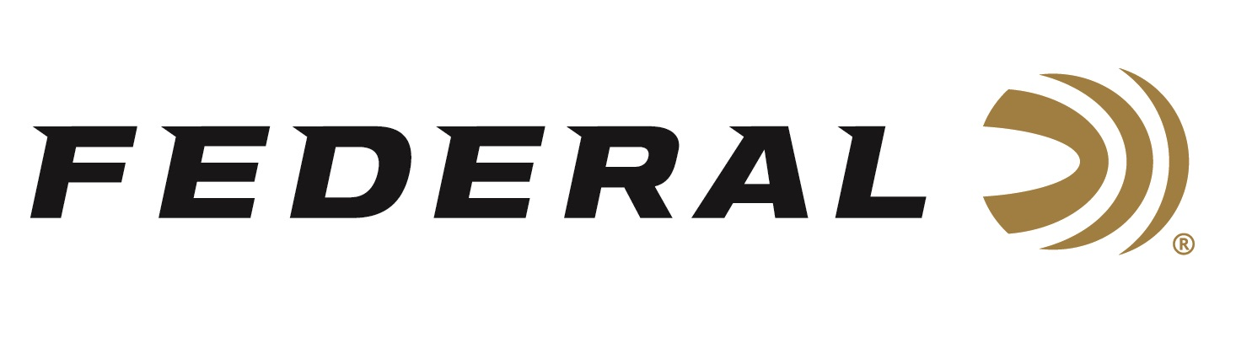

FOR IMMEDIATE RELEASE

Federal Ammunition HammerDown 444 Marlin Now Available

ANOKA, Minnesota – June 27, 2023 – Federal Ammunition’s HammerDown is in the industry’s only ammunition product line truly designed for optimal cycling and overall performance from the time-tested, lever-action rifle platform. Federal successfully launched Its HammerDown line in 2020, and today the product lineup includes options such as 357 Mag., 44 Mag., 30-30 Win., 45-70 Government, and more. Currently, the new 444 Marlin, 270-grain load is now available at select dealers.

“We are excited to add 444 Marlin to the overall HammerDown lineup. It is another great straight-wall cartridge that hunters and shooters are actively seeking it out,” said Federal Ammunition Centerfire Rifle Product Manager Eric Miller. “The powerful stopping power of the 444 Marlin has been shown to be an efficient for big-game hunting since its introduction in 1964.”

The velocities of all-new HammerDown offerings are customized to produce superior ballistics and terminal performance through lever-action barrel lengths. The construction of the molecularly bonded soft point bullets has also been adjusted for the best accuracy and expansion at those velocities. The geometry of each round’s case, bullet and cartridge ensures flawless cycling through tubular magazine and typical lever-action feeding systems. HammerDown is now offered in .45 Colt, 35 Remington and 444 Marlin in addition to the original loadings of 30-30 Win., 357 Magnum, 327 Federal and 44 Rem. Magnum.

“One of the enhanced design features found in all HammerDown ammo is that we chamfered the front face of the case rim on all the nickel-plated cases. This removes any sharp edges to increase reliability of feeding,” continued Miller. “This feature essentially improves cycling in all lever-action feeding systems, such as side-gate loading and tubular magazines.”

Federal ammunition can be found at dealers nationwide or purchased online direct from Federal. For more information on all products from Federal or to shop online, visit www.federalpremium.com.

Press Release Contact: JJ Reich
Senior Manager – Press Relations
E-mail: VistaPressroom@VistaOutdoor.com

About Federal Ammunition
Federal, headquartered in Anoka, MN, is a brand of Vista Outdoor Inc., an outdoor sports and recreation company. From humble beginnings nestled among the lakes and woods of Minnesota, Federal Ammunition has evolved into one of the world's largest producers of sporting ammunition. Beginning in 1922, founding president, Charles L. Horn, paved the way for our success. Today, Federal carries on Horn's vision for quality products and service with the next generation of outdoorsmen and women. We maintain our position as experts in the science of ammunition production. Every day we manufacture products to enhance our customers' shooting experience while partnering with the conservation organizations that protect and support our outdoor heritage. We offer thousands of options in our Federal Premium and Federal® lines-it's what makes us the most complete ammunition company in the business and provides our customers with a choice no matter their pursuit.

