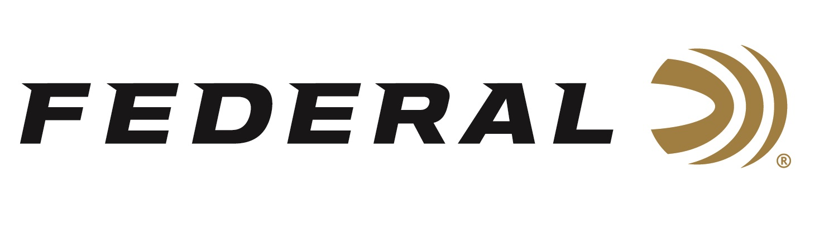

FOR IMMEDIATE RELEASE

Federal Ammunition Sponsored Shooter Hancock Wins Gold at Pan American Games

ANOKA, Minnesota – October 24, 2023 – Federal Ammunition congratulates sponsored shooter Vincent Hancock on winning two gold medals at the Pan American Games in Santiago, Chile. Hancock, a three-time Olympic gold medalist, won the Men’s Skeet event as well as teaming up with Dania Vizzi to claim the Mixed Team Skeet competition.

Hancock claimed his third Pan American Games individual gold medal in record performance on Sunday with a qualification score of 125. The 34-year-old Hancock missed only three targets in the final to finish ahead of competitors from Argentina and Peru. Hancock last won Pan American titles in 2009 and 2011.

Hancock, one of the USA flag bearers during the opening ceremonies, teamed with Dania Vizzi to capture gold in the Mixed Team Skeet event on Monday. The duo qualified first and then defeated Team Mexico in the finals to capture gold. Federal’s sponsored athlete Austen Smith and her teammate Dustan Taylor combined to capture the bronze medal in the Mixed Team Skeet event by defeating Team Chile.

Derrick Mein will take to the trap field on Thursday looking for gold in Chile.

Federal is the number one choice for shotgun shells and manufactures product in America for all competitive and recreational disciplines. See the full lineup, including the latest High Over All, at www.federalpremium.com.

Federal ammunition can be found at dealers nationwide. For more information on all products from Federal or to shop online, visit www.federalpremium.com.

Photo Credit: USA Shooting

Press Release Contact: JJ Reich
Senior Manager – Press Relations
E-mail: VistaPressroom@VistaOutdoor.com

About Federal Ammunition
Federal, headquartered in Anoka, MN, is a brand of Vista Outdoor Inc., an outdoor sports and recreation company. From humble beginnings nestled among the lakes and woods of Minnesota, Federal Ammunition has evolved into one of the world's largest producers of sporting ammunition. Beginning in 1922, founding president, Charles L. Horn, paved the way for our success. Today, Federal carries on Horn's vision for quality products and service with the next generation of outdoorsmen and women. We maintain our position as experts in the science of ammunition production. Every day we manufacture products to enhance our customers' shooting experience while partnering with the conservation organizations that protect and support our outdoor heritage. We offer thousands of options in our Federal Premium and Federal® lines-it's what makes us the most complete ammunition company in the business and provides our customers with a choice no matter their pursuit.

