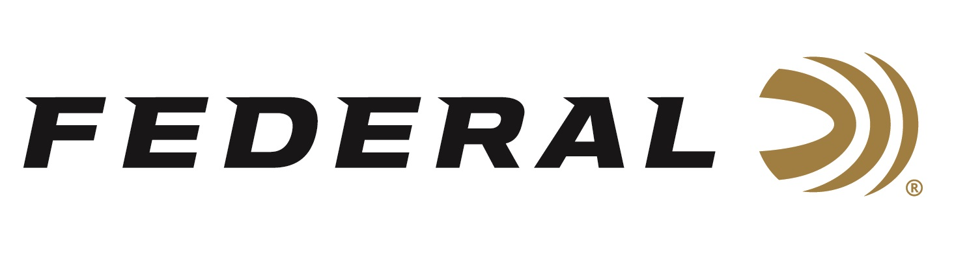

FOR IMMEDIATE RELEASE

Federal Ammunition Announces New Hi-Bird Upland Loads
with Fiber Wad

ANOKA, Minnesota – September 28, 2023 – Federal Ammunition announces a new line extension to its popular Hi-Bird upland game hunting product line. Hi-Bird Fiber (Paper) Wad’s cellulose wad construction helps minimize plastic left in the field, yet still offers the same hard-hitting performance as the original.

Hi-Bird | Federal Ammunition (federalpremium.com)

“The patented design of the fiber over-powder wad creates an effective gas seal, and the paper shot cup is designed to prevent barrel/shot contact and improve pattern performance,” said Dan Compton, Federal Shotshell Product Line Director. “Additionally, the overall fiber/paper wad system design helps reduce a shooter’s environmental impact on high-volume shoots.”

The new 12-gauge, No. 5 load’s high velocity (1,330 fps) and specially formulated lead shot produce downrange energy and pattern density that efficiently takes down birds at all shootable ranges. It’s available in 25-count boxes with an MSRP of $24.99.

“This new product was motivated by a customer need, because certain ranges and areas are beginning to require plastic-free wadding,” continued Compton. “We also offer the paper wad in cartridges tailored for the dove hunting and sporting target market, such as our Upland Steel and Top Gun loads.”

For more information on all products from Federal or to shop online, visit www.federalpremium.com.

Press Release Contact: JJ Reich
Senior Manager – Press Relations
E-mail: VistaPressroom@VistaOutdoor.com

About Federal Ammunition
Federal, headquartered in Anoka, MN, is a brand of Vista Outdoor Inc., an outdoor sports and recreation company. From humble beginnings nestled among the lakes and woods of Minnesota, Federal Ammunition has evolved into one of the world's largest producers of sporting ammunition. Beginning in 1922, founding president, Charles L. Horn, paved the way for our success. Today, Federal carries on Horn's vision for quality products and service with the next generation of outdoorsmen and women. We maintain our position as experts in the science of ammunition production. Every day we manufacture products to enhance our customers' shooting experience while partnering with the conservation organizations that protect and support our outdoor heritage. We offer thousands of options in our Federal Premium and Federal® lines-it's what makes us the most complete ammunition company in the business and provides our customers with a choice no matter their pursuit.

