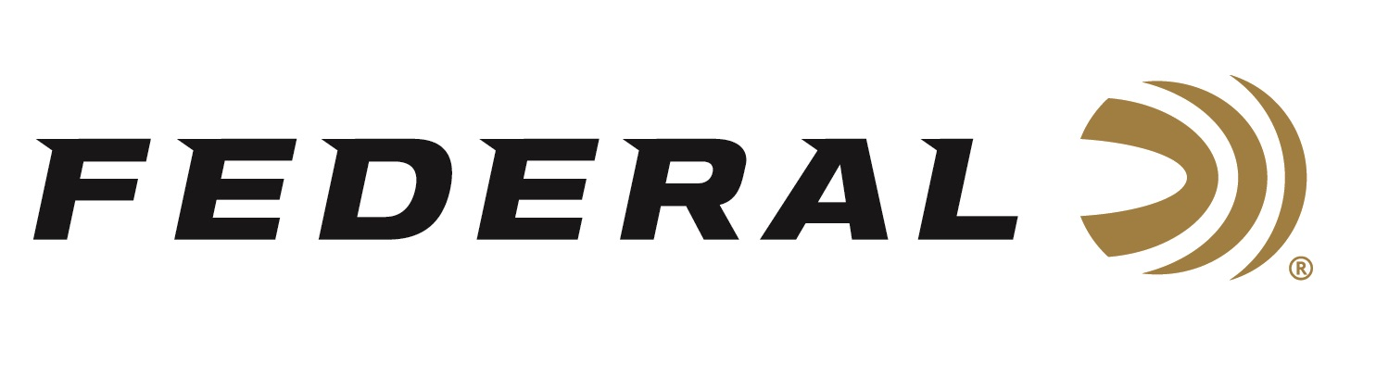

FOR IMMEDIATE RELEASE

Federal Ammunition Continues Strong Support for the International Hunter Education Association-USA

ANOKA, Minnesota – July 5, 2023 – Federal continues to support the International Hunter Education Association to promote safe shooting and hunting education programs, by sponsoring a Range Day during the conference that was held June 26-29th in Boise, Idaho. Hunter Education professionals and volunteers from all over the country gathered in Boise, ID to learn best practices, share training tactics and learn from industry experts to help support safe hunting and sport shooting across all ages.

“Federal continues to support hunters’ safety and firearm safety across the country. It is a top priority for us. We are proud to support the conference again this year and provide them the highest quality American-made ammunition for their field day at the Idaho Game and Fish Black’s Creek Public Shooting range,” said Jon Zinnel, Federal’s Senior Manager of Education and Conservation Programs. “Protecting our heritage is in our mission statement and supporting IHEA in their efforts is a direct connection to this mission.”

The International Hunter Education Association-USA is a 501c3 non-profit organization that works with State Wildlife Agencies, other national government organizations and the firearms industry to further the initiative of hunter safety and education on wildlife conservation. Federal has sponsored the IHEA-USA for more than a decade. Most notably, Federal sponsors the annual ‘Hunter Education Instructor of the Year’ award as well as the annual IHEA-USA Conference each year.

For more on IHEA-USA and to learn how you can help support the future of hunting and hunter education, visit www.ihea.com.

Federal ammunition can be found at dealers nationwide. For more information on all products from Federal or to shop online, visit www.federalpremium.com.

Press Release Contact: JJ Reich
Senior Manager – Press Relations
E-mail: VistaPressroom@VistaOutdoor.com

About Federal Ammunition
Federal, headquartered in Anoka, MN, is a brand of Vista Outdoor Inc., an outdoor sports and recreation company. From humble beginnings nestled among the lakes and woods of Minnesota, Federal Ammunition has evolved into one of the world's largest producers of sporting ammunition. Beginning in 1922, founding president, Charles L. Horn, paved the way for our success. Today, Federal carries on Horn's vision for quality products and service with the next generation of outdoorsmen and women. We maintain our position as experts in the science of ammunition production. Every day we manufacture products to enhance our customers' shooting experience while partnering with the conservation organizations that protect and support our outdoor heritage. We offer thousands of options in our Federal Premium and Federal® lines-it's what makes us the most complete ammunition company in the business and provides our customers with a choice no matter their pursuit.

