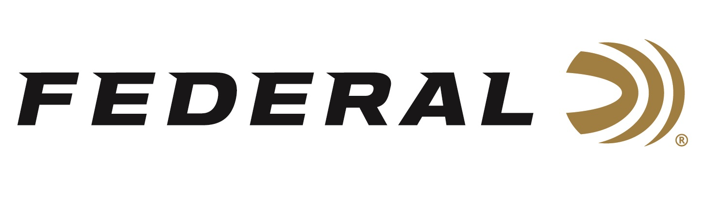

FOR IMMEDIATE RELEASE

Federal Ammunition Will Showcase New Products at the 2023 NRA Annual Meetings & Exhibits

ANOKA, Minnesota – April 10, 2023 – Federal Ammunition will unveil new products at the 2023 NRA Annual Meetings & Exhibits, held at the Indiana Convention Center, on April 14-16, 2023 in Indianapolis, Indiana. Attendees are encouraged to visit booth 5355 to see all of Federal’s new products for 2023, which includes new 7mm PRC cartridges in 155-grain and 170-grain Terminal Ascent.

“The new 7mm PRC cartridge is built for long-range hunting, delivering magnum power from a standard-action rifle platform with streamlined, heavy-for-caliber bullets,” said Federal’s Centerfire Product Line Manager, Eric Miller. “Federal is maximizing the accuracy, range and terminal performance of the 7mm PRC with three new offerings.”

Features of these new cartridges include: all-new standard-action centerfire rifle cartridge; high ballistic coefficient (BC), heavy-for-caliber bullets; available in Terminal Ascent or ELD-X bullets; and loaded with Gold Medal primers, specially formulated propellant, and Premium brass.

“We looked at the 7mm PRC and it’s capabilities as a new cartridge and knew that paired with Terminal Ascent, we would have a fantastic load for the hunter and shooter,” continued Miller. “With the faster twist rates, the high BC and long ogive in Terminal Ascent is a great combination for the hunter and shooter. People will like the energy that the .284-inch caliber carries, and through our test shooting we are extremely pleased with the accuracy of these new loads.”

The 2023 NRA Annual Meetings & Exhibits will showcase over 14 acres of the latest guns and gear. Learn more at: www.nraam.org.

Federal ammunition can be found at dealers nationwide. For more on Federal ammunition or to shop online, visit www.federalpremium.com.

Press Release Contact: JJ Reich
Senior Communications Manager - Firearms and Ammunition
E-mail: VistaPressroom@VistaOutdoor.com

About Federal Ammunition
Federal, headquartered in Anoka, MN, is a brand of Vista Outdoor Inc., an outdoor sports and recreation company. From humble beginnings nestled among the lakes and woods of Minnesota, Federal Ammunition has evolved into one of the world's largest producers of sporting ammunition. Beginning in 1922, founding president, Charles L. Horn, paved the way for our success. Today, Federal carries on Horn's vision for quality products and service with the next generation of outdoorsmen and women. We maintain our position as experts in the science of ammunition production. Every day we manufacture products to enhance our customers' shooting experience while partnering with the conservation organizations that protect and support our outdoor heritage. We offer thousands of options in our Federal Premium and Federal® lines-it's what makes us the most complete ammunition company in the business and provides our customers with a choice no matter their pursuit.

