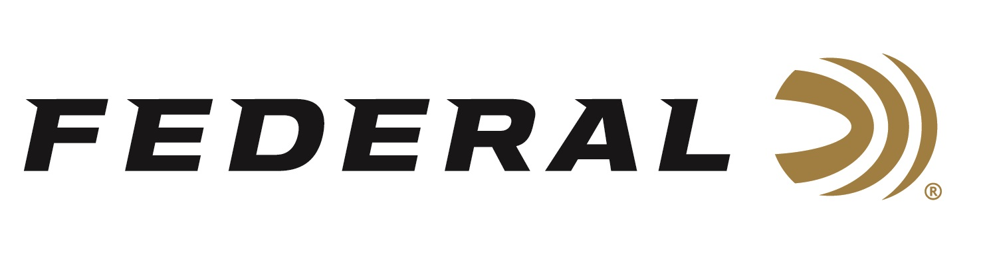

FOR IMMEDIATE RELEASE

Federal Ammunition Will Host Medal of Honor Recipient Sammy Davis at the 2023 NRA Show

ANOKA, Minnesota – April 11, 2023 – Federal Ammunition is proud to host Sammy Davis, Medal of Honor Recipient, in booth 5355 at the 2023 NRA Annual Meetings & Exhibits, held at the Indiana Convention Center, on April 14-16, 2023 in Indianapolis, Indiana. Attendees are encouraged to visit with Davis on Friday, April 14 from 10 a.m. until 2 p.m. During that time, Davis will visit with NRA members and sign autographs.

“U.S. Army Private First Class Sammy Lee Davis was presented the Medal of Honor for military valor during the Vietnam War. We are excited to have him in our booth at this year’s NRA Show,” said Federal Ammunition Vice President of Marketing, Jason Nash. “The Medal of Honor is awarded for conspicuous gallantry and intrepidity in action at the risk of his life above and beyond the call of duty. It is truly an honor to have such a respected veteran visit with us and our customers during this event.”

Davis’s book entitled “You Don't Lose 'Til You Quit Trying: Lessons on Adversity and Victory from a Vietnam Veteran and Medal of Honor Recipient” is the inspiring true life story of Vietnam veteran, Medal of Honor Recipient and veteran’s advocate Sammy Lee Davis. Copies of this book will be on sale during this meet-and-greet session at Federal’s booth and can be signed by the author.

The video: Sammy Davis, Medal of Honor, Vietnam War currently has 1.4 million views on YouTube, which can be viewed at: https://youtu.be/aOWBw7muH9M.

The 2023 NRA Annual Meetings & Exhibits will showcase over 14 acres of the latest guns and gear. Learn more at: www.nraam.org.

Federal ammunition can be found at dealers nationwide. For more on Federal ammunition or to shop online, visit www.federalpremium.com.

Press Release Contact: JJ Reich
Senior Communications Manager - Firearms and Ammunition
E-mail: VistaPressroom@VistaOutdoor.com

About Federal Ammunition
Federal, headquartered in Anoka, MN, is a brand of Vista Outdoor Inc., an outdoor sports and recreation company. From humble beginnings nestled among the lakes and woods of Minnesota, Federal Ammunition has evolved into one of the world's largest producers of sporting ammunition. Beginning in 1922, founding president, Charles L. Horn, paved the way for our success. Today, Federal carries on Horn's vision for quality products and service with the next generation of outdoorsmen and women. We maintain our position as experts in the science of ammunition production. Every day we manufacture products to enhance our customers' shooting experience while partnering with the conservation organizations that protect and support our outdoor heritage. We offer thousands of options in our Federal Premium and Federal® lines-it's what makes us the most complete ammunition company in the business and provides our customers with a choice no matter their pursuit.

