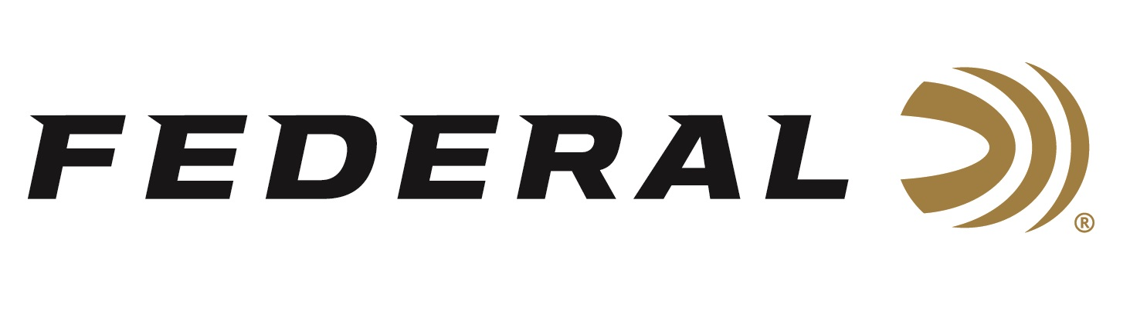
FOR IMMEDIATE RELEASE

Federal Ammunition Helps the National Wild Turkey Federation Celebrate 50 Years of Turkey Conservation

ANOKA, Minnesota – July 25, 2023 – Federal Ammunition joined the National Wild Turkey Federation (NWTF) for a celebration of the NWTF’s 50-year Anniversary and the restoration of the wild turkeys in Minnesota. The event was held July 22, 2023 in Caledonia, Minnesota, where wild turkeys were first reintroduced in the state, in the early 1970s.

“Historically, Minnesota was the northern edge of the wild turkey range. Birds have naturally thrived in limited numbers only in the southern part of the state,” said Jon Zinnel, Federal’s Senior Manager of Education and Conservation Programs. “However, over the past 50 years, the NWTF in Minnesota collaborated on relocating wild turkeys, as well as creating wild turkey habitat, across the entire state. The result is an abundance of wild turkeys currently thriving in Minnesota. The opportunity to hunt wild turkeys during the allowed seasons has been incredible. We are thankful and appreciative for all the NWTF’s efforts.”

“We were excited to gather all of our partners, volunteers, and major donors from across the state to celebrate one of America’s greatest wildlife conservation success stories, both across the nation and here in Minnesota,” said Tom Glines, NWTF’s Director of Development. “As part of the overall celebration event, we gathered in Caledonia’s North Park to dedicate three bronze cairns that commemorate the amazing restoration of the wild turkey in Minnesota and all of those who made it possible.”

“We are proud of our long span of support for the NWTF over the past five decades, and we look forward to continuing to support this strong conservation organization, as they continue their mission,” said Zinnel. “The royalty program we have set with NWTF is on our full suite of turkey products which contributes to NWTF’s annual funding: Everything from Federal Premium Heavyweight TSS down to our copper-plated lead loads in our Grand Slam lineup is part of this program. Hunters can easily support NWTF by simply buying our turkey loads every season.”

For more information on all products from Federal or to shop online, visit www.federalpremium.com.

Press Release Contact: JJ Reich
Senior Manager – Press Relations
E-mail: VistaPressroom@VistaOutdoor.com

About Federal Ammunition
Federal, headquartered in Anoka, MN, is a brand of Vista Outdoor Inc., an outdoor sports and recreation company. From humble beginnings nestled among the lakes and woods of Minnesota, Federal Ammunition has evolved into one of the world's largest producers of sporting ammunition. Beginning in 1922, founding president, Charles L. Horn, paved the way for our success. Today, Federal carries on Horn's vision for quality products and service with the next generation of outdoorsmen and women. We maintain our position as experts in the science of ammunition production. Every day we manufacture products to enhance our customers' shooting experience while partnering with the conservation organizations that protect and support our outdoor heritage. We offer thousands of options in our Federal Premium and Federal® lines-it's what makes us the most complete ammunition company in the business and provides our customers with a choice no matter their pursuit.

