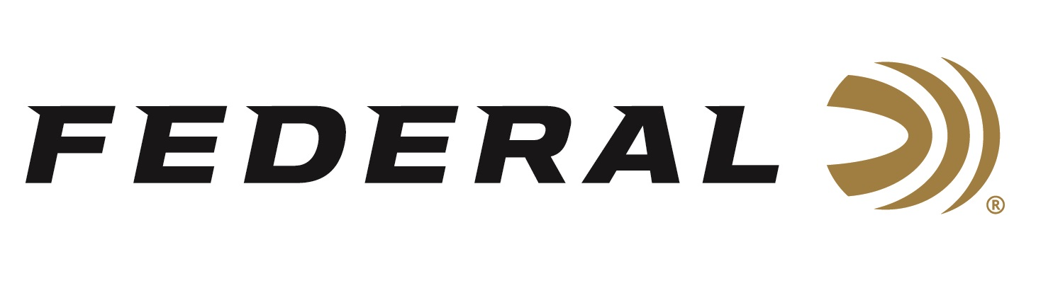
FOR IMMEDIATE RELEASE

Federal Ammunition is Proud to Sponsor NWTF’s 2023 Convention and Sport Show for 40th Year

ANOKA, Minnesota – February 9, 2023 – Federal Ammunition is proud to be the title sponsor of the Hunting Heritage Breakfast on Friday February 17 at the National Wild Turkey Federation’s (NWTF) 47th Annual Convention and Sport Show. The 2023 NWTF Convention, held February 15-19, 2023 in Nashville, Tennessee, will be a celebration of the NWTF’s 50th Anniversary. Federal Premium Ammunition also continues as a Gobbler Sponsor of the overall event.

“NWTF continues its longtime support towards conservation across the country. The projects supported by NWTF, which supports the livelihood of wild turkeys, also benefits hundreds of other species along the way. Visiting with NWTF members from across the country reaffirms the passion and drive of their membership to support conservation of all species,” said Senior Conservation Manager for Federal Ammunition, Jon Zinnel. “Federal and NWTF have had a longstanding relationship which has continued over four decades. We look forward to many more years of working together as NWTF comes up on their 50th anniversary in 2023.”

Federal Ammunition and the National Wild Turkey Federation have been working hand in hand for decades. The company has participated at every NWTF convention and has hosted the Conservation Breakfast for 40 years. Federal Ammunition is one of the five longest-running sponsors and the only licensed ammunition partner of the NWTF.

“We appreciate everything NWTF members do to grow our sport and pass along our great hunting heritage,” continued Zinnel. “With turkey populations in decent shape throughout much of the country, hunters anticipate a memorable 2023 season. Now they can go afield knowing Federal’s new Premium turkey loads will not only deliver consistent, devastating performance, but also help turkeys themselves through their partnership with the NWTF.”

For more information on all products from Federal or to shop online, visit www.federalpremium.com.

Press Release Contact: JJ Reich
Senior Manager – Press Relations
E-mail: VistaPressroom@VistaOutdoor.com

About Federal Ammunition
Federal, headquartered in Anoka, MN, is a brand of Vista Outdoor Inc., an outdoor sports and recreation company. From humble beginnings nestled among the lakes and woods of Minnesota, Federal Ammunition has evolved into one of the world's largest producers of sporting ammunition. Beginning in 1922, founding president, Charles L. Horn, paved the way for our success. Today, Federal carries on Horn's vision for quality products and service with the next generation of outdoorsmen and women. We maintain our position as experts in the science of ammunition production. Every day we manufacture products to enhance our customers' shooting experience while partnering with the conservation organizations that protect and support our outdoor heritage. We offer thousands of options in our Federal Premium and Federal® lines-it's what makes us the most complete ammunition company in the business and provides our customers with a choice no matter their pursuit.

