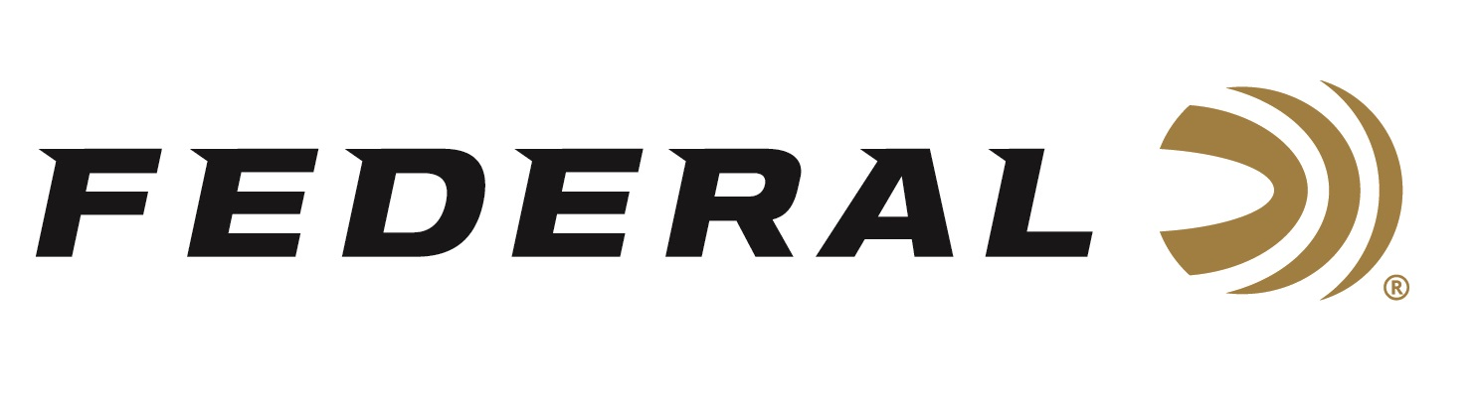

FOR IMMEDIATE RELEASE

Federal Ammunition is the Presenting Sponsor for the 2023
Pheasant Fest & Quail Classic

ANOKA, Minnesota – February 10, 2023 – Federal Ammunition is proud to be the Presenting Sponsor for the Pheasant Fest and Quail Classic held in Minneapolis, Minnesota, February 17-19. The event will bring together tens of thousands of upland hunting enthusiasts to see all the best new products including Federal Premium’s lineup of Pheasants Forever and Quail Forever branded product lines.

“Pheasants Forever and Quail Forever continue to lead the path for upland conservation and have done a tremendous job under Howard Vincent’s leadership, for the past several decades,” said Jon Zinnel, Senior Manager for Federal’s Conservation programs. “We commend Howard for his enthusiastic leadership of the organization, and we also look forward to working with incoming CEO Marilyn Vetter, who is debuting at this year’s Pheasant Fest and Quail Classic.”

Pheasants Forever and Quail Forever will be offering a full lineup of free seminars for attendees, as well as access to vendor booths, workshops, youth activities, and many other show floor activities. Attendees are encouraged to stop by Federal’s booth No. 1835 to talk with Federal’s passionate staff about the perfect ammunition for any upcoming upland hunting adventure.

“At this event, Pheasants Forever is celebrating 40 years of conservation success,” continued Zinnel. “We look forward to its bright future as it continues its conservation efforts across the country, and we are excited to continue collaborating closely with them for many more years to come.”

Pheasants Forever, including its quail conservation division, Quail Forever, is the nation's largest nonprofit organization dedicated to upland habitat conservation. Their mission is to conserve pheasants, quail, and other wildlife through habitat improvements, public access, education, and conservation advocacy. For more information, go to www.pheasantsforever.org.

Federal ammunition can be found at dealers nationwide. For more information on all products from Federal or to shop online, visit www.federalpremium.com.

Press Release Contact: JJ Reich
Senior Manager – Press Relations
E-mail: VistaPressroom@VistaOutdoor.com

About Federal Ammunition
Federal, headquartered in Anoka, MN, is a brand of Vista Outdoor Inc., an outdoor sports and recreation company. From humble beginnings nestled among the lakes and woods of Minnesota, Federal Ammunition has evolved into one of the world's largest producers of sporting ammunition. Beginning in 1922, founding president, Charles L. Horn, paved the way for our success. Today, Federal carries on Horn's vision for quality products and service with the next generation of outdoorsmen and women. We maintain our position as experts in the science of ammunition production. Every day we manufacture products to enhance our customers' shooting experience while partnering with the conservation organizations that protect and support our outdoor heritage. We offer thousands of options in our Federal Premium and Federal lines-it's what makes us the most complete ammunition company in the business and provides our customers with a choice no matter their pursuit.

