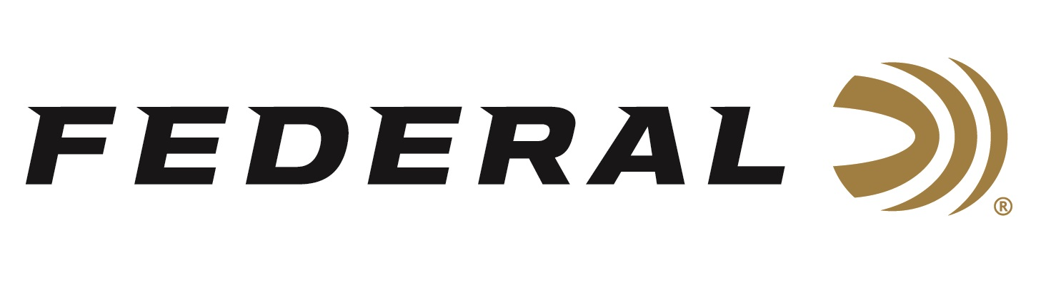

FOR IMMEDIATE RELEASE

Federal Ammunition’s New Podium Wad is Available for Shotshell Reloaders

ANOKA, Minnesota – November 16, 2023 – Federal Ammunition’s Podium Wad—a featured component in Federal Premium’s High Over All (HOA) competition-grade target loads—is available for the general shotshell reloading market.

Podium Wad | Federal Ammunition

“Reloaders can now craft their next victory with the wad that's transforming clay target shooting,” said Federal Shotshell Product Director Dan Compton. “Our unique Podium Wads drive peak performance in the best competition target loads we make, and they’re now available as a component for reloading.”

The Podium Wad’s cylinder-shaped compression zone supports the payload at ignition for softer shooting. It also provides unmatched protection from deformation of the shot pellets at ignition, helping to deliver the best patterns with fewer flyers. Plus, the wad’s unique profile shape allows it to be loaded in all tapered hulls.

“HOA factory loads leave a trail of shattered targets in its wake and provides more reloads per shell. It’s hard, high-antimony lead payload and exclusive one-piece Podium Wad produce the most consistent patterns, while the solid brass head and tapered, one-piece hull make reloading easier than ever,” continued Compton. “We’ve virtually eliminated flyers with the Podium Wad, and with so many customers asking for it as a reloading component, it just makes sense to offer the Podium Wad in our catalog because our HOA hulls can be reloaded many times.”

Federal’s Podium Wads are available in both 1- and 1 1/8-ounce configurations; 500-count bags; MSRP: $18.99.

For more information on all products from Federal or to shop online, visit www.federalpremium.com.

Press Release Contact: JJ Reich
Senior Manager – Press Relations
E-mail: VistaPressroom@VistaOutdoor.com
About Federal Ammunition
Federal, headquartered in Anoka, MN, is a brand of Vista Outdoor Inc., an outdoor sports and recreation company. From humble beginnings nestled among the lakes and woods of Minnesota, Federal Ammunition has evolved into one of the world's largest producers of sporting ammunition. Beginning in 1922, founding president, Charles L. Horn, paved the way for our success. Today, Federal carries on Horn's vision for quality products and service with the next generation of outdoorsmen and women. We maintain our position as experts in the science of ammunition production. Every day we manufacture products to enhance our customers' shooting experience while partnering with the conservation organizations that protect and support our outdoor heritage. We offer thousands of options in our Federal Premium and Federal® lines-it's what makes us the most complete ammunition company in the business and provides our customers with a choice no matter their pursuit.

