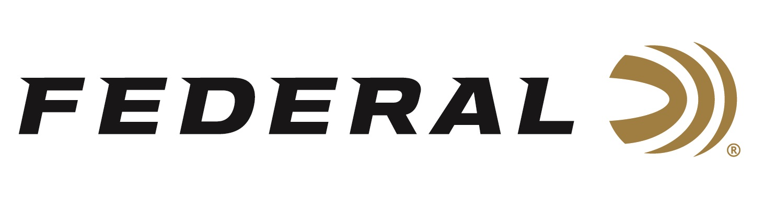

FOR IMMEDIATE RELEASE

Federal Ammunition Announces A New Power-Shok No. 1 Buck Load

ANOKA, Minnesota – October 30, 2023 – Federal Ammunition adds size No. 1 to its popular Power-Shok buckshot product line. Hunters will now have a great option for hogs, predators and more with the new Power-Shok No. 1 buck offering. The load provides the patterns and terminal performance needed, thanks to the Triple Plus wad system, quality lead pellets and granulated plastic buffer that minimizes shot deformation.

Power-Shok Buckshot 12 Gauge F127 1B | Federal Ammunition

“No. 1 Buck has really grown in popularity over the past several years and we wanted to deliver on what hunters and shooters are looking for,” said Federal Shotshell Product Director Dan Compton. “These new loads produce good patterns with lots of pellets on target.”

Summary of features include: New 16-pellet No. 1 buck offering; 12-gauge, 2 ¾-inch magnum load with 1,325 feet-per-second muzzle velocity; Triple Plus wad system provides better shot alignment; Granulated plastic buffer keeps pellets uniform in shape; Tight downrange patterns; Quality lead pellets; 5-round boxes; MSRP: $9.99.

For more information on all products from Federal or to shop online, visit www.federalpremium.com.

Press Release Contact: JJ Reich
Senior Manager – Press Relations
E-mail: VistaPressroom@VistaOutdoor.com

About Federal Ammunition
Federal, headquartered in Anoka, MN, is a brand of Vista Outdoor Inc., an outdoor sports and recreation company. From humble beginnings nestled among the lakes and woods of Minnesota, Federal Ammunition has evolved into one of the world's largest producers of sporting ammunition. Beginning in 1922, founding president, Charles L. Horn, paved the way for our success. Today, Federal carries on Horn's vision for quality products and service with the next generation of outdoorsmen and women. We maintain our position as experts in the science of ammunition production. Every day we manufacture products to enhance our customers' shooting experience while partnering with the conservation organizations that protect and support our outdoor heritage. We offer thousands of options in our Federal Premium and Federal® lines-it's what makes us the most complete ammunition company in the business and provides our customers with a choice no matter their pursuit.

