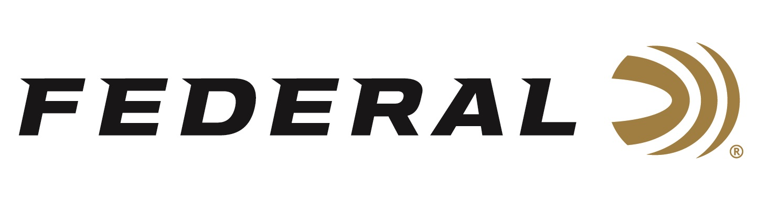

FOR IMMEDIATE RELEASE

Federal Ammunition Announces A New Premium 1 Buck Load

ANOKA, Minnesota – October 10, 2023 – Federal Ammunition announces a new offering in its Premium buckshot line. Federal makes its Premium line of shotshells to provide precision performance. The new 12-gauge, No. 1 buck is no exception. Its payload of 16 copper-plated pellets produces tight patterns for more hits and better stopping power on predators, deer, hogs and more.

Buckshot 12 Gauge P154 1B | Federal Ammunition

“Copper-plated No. 1 Buckshot really rounds off our Premium buckshot lineup,” said Federal Shotshell Product Director Dan Compton. “No. 1 Buck really lands in a sweet spot, overall. It delivers increased pellet counts compared to larger buckshot sizes. Yet also provides greater energy and penetration on target than smaller buckshot sizes.”

Summary of features include: 16-pellets of No. 1 Buck copper-plated lead shot; 12-gauge, 2 ¾-inch magnum load with 1,325 feet-per-second muzzle velocity; Use of buffer to prevent pellet deformation and ensure dense, uniform patterns; Premium-quality wad, hull, primer; Enhanced manufacturing quality tests and checks; 5-round boxes; MSRP: $15.99.

For more information on all products from Federal or to shop online, visit www.federalpremium.com.

Press Release Contact: JJ Reich
Senior Manager – Press Relations
E-mail: VistaPressroom@VistaOutdoor.com

About Federal Ammunition
Federal, headquartered in Anoka, MN, is a brand of Vista Outdoor Inc., an outdoor sports and recreation company. From humble beginnings nestled among the lakes and woods of Minnesota, Federal Ammunition has evolved into one of the world's largest producers of sporting ammunition. Beginning in 1922, founding president, Charles L. Horn, paved the way for our success. Today, Federal carries on Horn's vision for quality products and service with the next generation of outdoorsmen and women. We maintain our position as experts in the science of ammunition production. Every day we manufacture products to enhance our customers' shooting experience while partnering with the conservation organizations that protect and support our outdoor heritage. We offer thousands of options in our Federal Premium and Federal® lines-it's what makes us the most complete ammunition company in the business and provides our customers with a choice no matter their pursuit.

