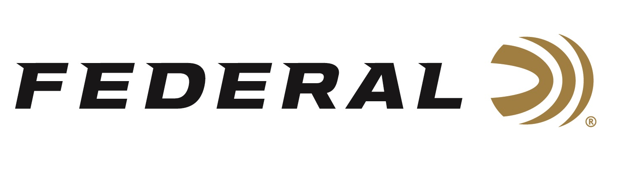

FOR IMMEDIATE RELEASE

Federal Ammunition Introduces New Premium ELD-X Hunting Loads

ANOKA, Minnesota – June 19, 2023 – Federal Ammunition introduces an expansion of its line of Premium hunting loads to now feature Hornady ELD-X hunting bullets. The new offerings will be loaded in Federal’s Anoka, Minnesota factory. The full lineup will soon be available in ten centerfire cartridge options from 243 Win. to 300 Win. Magnum. Currently, ELD-X 7MM PRC 175-grain is available online: ELD-X 7MM PRC P7PRCELDX1 (federalpremium.com)

“Continuing the tradition of Federal Premium—which means loading the most popular bullets—we now are loading ELD-X bullets,” said Federal’s Senior Director of Product Management, Jesse Whiteside. “ELD-X bullets are very accurate and we are holding this bullet to our highest standards of our Premium specifications. Our customers requested these bullets in factory-loaded ammunition, and we are happy to deliver on our customers’ needs.”

The match-accurate, hard-hitting ELD-X hunting bullet features an extremely high-ballistic coefficient in a design that provides effective expansion at a wide range of velocities. The bullet features a unique polymer tip that resists deformation to achieve consistent ballistics and initiate extreme-range expansion. It also touts an aerodynamic secant ogive and optimized boat-tail, plus a concentric copper jacket with robust shank.

Summary of cartridges include: 243 Win., 90-grain; 6.5 Creedmoor, 143-grain; 6.5 PRC, 143-grain; 270 Win., 145-grain; 7mm Rem. Magnum, 162-grain; 7mm PRC, 175-grain, 308 Win., 178-grain; 30-06 Sprg.,178-grain; 300 WSM, 200-grain; and 300 Win. Mag., 200-grain.

The load also features specially formulated propellant and nickel-plated brass. It is packaged in 20-round boxes; MSRP: $52.99-82.99.

For more information on all products from Federal or to shop online, visit www.federalpremium.com.

Press Release Contact: JJ Reich
Senior Manager – Press Relations
E-mail: VistaPressroom@VistaOutdoor.com

About Federal Ammunition
Federal, headquartered in Anoka, MN, is a brand of Vista Outdoor Inc., an outdoor sports and recreation company. From humble beginnings nestled among the lakes and woods of Minnesota, Federal Ammunition has evolved into one of the world's largest producers of sporting ammunition. Beginning in 1922, founding president, Charles L. Horn, paved the way for our success. Today, Federal carries on Horn's vision for quality products and service with the next generation of outdoorsmen and women. We maintain our position as experts in the science of ammunition production. Every day we manufacture products to enhance our customers' shooting experience while partnering with the conservation organizations that protect and support our outdoor heritage. We offer thousands of options in our Federal Premium and Federal® lines-it's what makes us the most complete ammunition company in the business and provides our customers with a choice no matter their pursuit.

