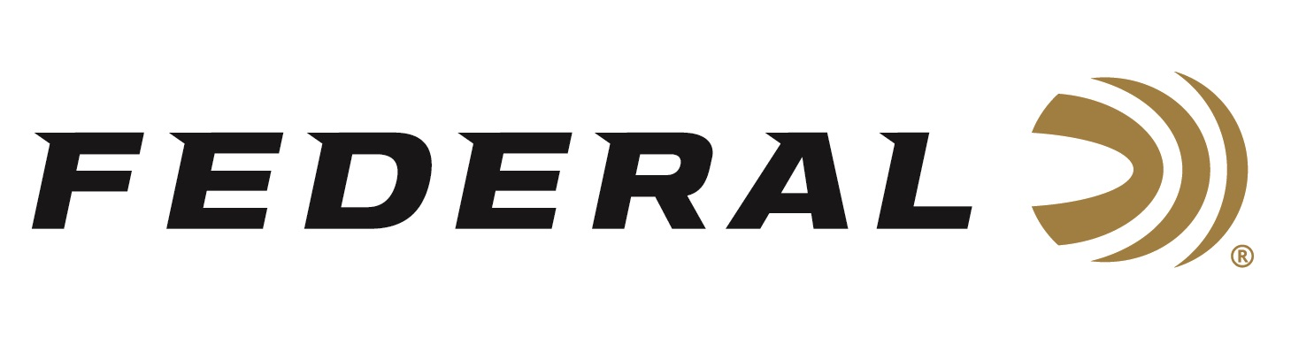
FOR IMMEDIATE RELEASE

Federal Ammunition Launches Punch in 30 Super Carry

ANOKA, Minnesota – August 16, 2023 – Federal Ammunition announces a line extension to the Punch self-defense product family with the addition of the all-new 30 Super Carry Cartridge. Federal engineers designed both Punch ammunition and the new 30 Super Carry cartridge from the ground up for self-defense, and the two have come together in a load that shoots effectively.

Personal Defense Punch | Federal Ammunition

“With the successful launch of 30 Super Carry, we are incorporating feedback from end users on additional loads they’d like to see,” said Federal’s Handgun Product Line Director Nick Sachse. “Some match-ups are meant to be, and we are excited to offer now Punch in 30 Super Carry.”

Punch was specifically engineered to provide balanced terminal performance across different platforms and through the most common barriers. Similarly, Federal created the 30 Super Carry cartridge around the unique needs of self-defenders who carry concealed, delivering the power of 9mm Luger, with more magazine capacity and dramatically less recoil. The blending of the two technologies gives shooters an extremely easy-to-shoot and effective option for real-world defense.

“The 30 Super Carry Punch focuses on the benefit of reduced recoil, while providing balanced terminal performance of penetration and expansion, and working well through all barrel lengths,” explained Sachse.

Summary of features include significantly less recoil than 9mm Luger; same power as 9mm Luger with as many as 3 more rounds of magazine capacity in currently available handguns; balanced performance across different platforms and through the most common barriers; and the Punch 103-grain jacketed hollow-point bullet design. 30 Super Carry Punch comes in 20-count boxes with a MSRP of $26.99.

For more information on all products from Federal or to shop online, visit www.federalpremium.com.

Press Release Contact: JJ Reich
Senior Manager – Press Relations
E-mail: VistaPressroom@VistaOutdoor.com
About Federal Ammunition
Federal, headquartered in Anoka, MN, is a brand of Vista Outdoor Inc., an outdoor sports and recreation company. From humble beginnings nestled among the lakes and woods of Minnesota, Federal Ammunition has evolved into one of the world's largest producers of sporting ammunition. Beginning in 1922, founding president, Charles L. Horn, paved the way for our success. Today, Federal carries on Horn's vision for quality products and service with the next generation of outdoorsmen and women. We maintain our position as experts in the science of ammunition production. Every day we manufacture products to enhance our customers' shooting experience while partnering with the conservation organizations that protect and support our outdoor heritage. We offer thousands of options in our Federal Premium and Federal® lines-it's what makes us the most complete ammunition company in the business and provides our customers with a choice no matter their pursuit.

