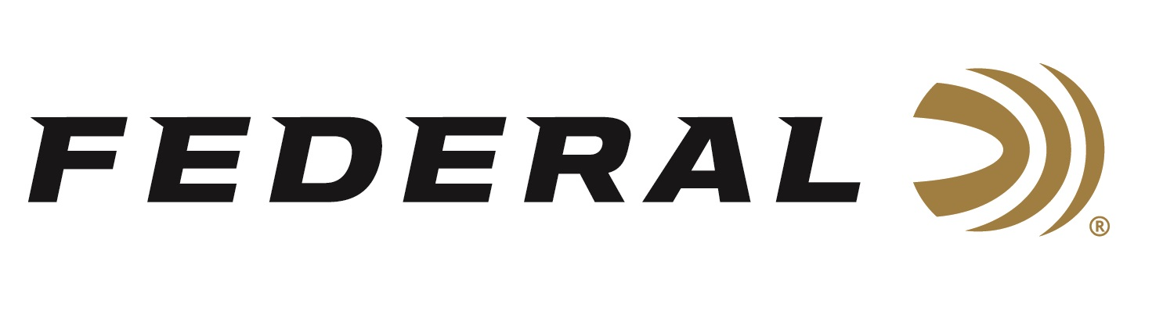

FOR IMMEDIATE RELEASE

Federal Ammunition Announces Black Pack Bucks Rebate Program for Black Friday

ANOKA, Minnesota – November 21, 2023 – Federal Premium announces its Black Friday Black Pack Bucks Rebate Program. This is a special one-month offer for cash back on 22 LR rimfire bulk packs. Customers can now buy a minimum of two qualifying boxes of Federal 1,100-round Black Pack rimfire ammunition and get $20 back.

“Our customers can get even more value from Federal Ammunition by taking advantage of rebates and promotions,” said Federal's Director of Trade Marketing Jill Karolewski. “Back by popular demand, customers can stock up on 22 LR rimfire bulk packs at various retail outlets. This quality ammunition certainly makes for great holiday gifts.”

This rebate is $10 per box. Minimum purchase of two (2), 1,100-round boxes required. Maximum rebate $100 (10 boxes) per person or household. Qualifying Federal Black Pack ammunition is limited to manufacturer part number 36BF1100, 36-grain lead hollow point, 1,100-round box.

Rebate is valid for purchases made November 19, 2023 through December 26, 2023. Deadline for online submission is January 10, 2024. Submitting online is fast and easy, on a computer, or on-the-go from a tablet or mobile device. Offer valid in the U.S. and Canada, U.S. funds only.

For complete details on rebate, visit: https://www.federalpremium.com/this-is-federal/rebates-and-promotions/.

For more information on all products from Federal or to shop online, visit www.federalpremium.com.

Press Release Contact: JJ Reich
Senior Manager – Press Relations
E-mail: VistaPressroom@VistaOutdoor.com

About Federal Ammunition
Federal, headquartered in Anoka, MN, is a brand of Vista Outdoor Inc., an outdoor sports and recreation company. From humble beginnings nestled among the lakes and woods of Minnesota, Federal Ammunition has evolved into one of the world's largest producers of sporting ammunition. Beginning in 1922, founding president, Charles L. Horn, paved the way for our success. Today, Federal carries on Horn's vision for quality products and service with the next generation of outdoorsmen and women. We maintain our position as experts in the science of ammunition production. Every day we manufacture products to enhance our customers' shooting experience while partnering with the conservation organizations that protect and support our outdoor heritage. We offer thousands of options in our Federal Premium and Federal® lines-it's what makes us the most complete ammunition company in the business and provides our customers with a choice no matter their pursuit.

