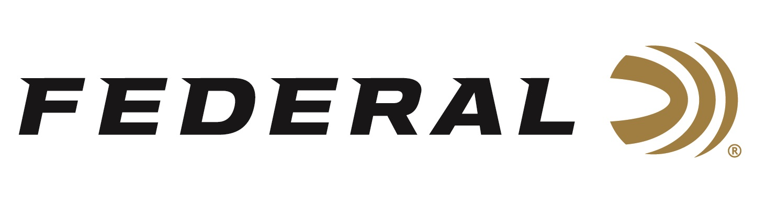

FOR IMMEDIATE RELEASE

Federal Ammunition Continues Support for the Scholastic Clay Target Program

ANOKA, Minnesota – July 27, 2023 – Federal Ammunition is proud to continue its dedicated support for the Scholastic Clay Target Program (SCTP). Part of this support includes participating as a Gold level sponsor of the 2023 SCTP National Championships, recently held at the Cardinal Center in Marengo, Ohio. Thousands of youth participants from dozens of states attended the event.

The Scholastic Clay Target Program is one of the largest, fastest growing, and most exciting youth clay target programs in the US. They provide students from elementary through high school and college the chance to compete in sports such as trap, skeet, sporting clays and Olympic disciplines like bunker trap and international skeet.

“Our continued sponsorship SCTP organization affirms our commitment to youth shooting sports and promoting firearm safety. We are quite happy to see this program continues to grow and expand across the country,” said Jon Zinnel, Federal’s Senior Manager of Education and Conservation Programs. “The National Tournament provides a highly competitive environment while promoting the highest level of safety across the shooting ranges. Teams, Coaches, Parents and Spectators gather from across the country to shoot and compete; all while promoting firearm safety and sportsmanship.”

The SCTP’s mission is to help kids reach their highest potential in becoming the best athlete and young adults they can be. The SCTP is a youth development program, primarily and we do this through the shooting sports and competitive shooting. Learn more at: https://mysctp.com.

For more information on all products from Federal or to shop online, visit www.federalpremium.com.

Press Release Contact: JJ Reich
Senior Manager – Press Relations
E-mail: VistaPressroom@VistaOutdoor.com

About Federal Ammunition
Federal, headquartered in Anoka, MN, is a brand of Vista Outdoor Inc., an outdoor sports and recreation company. From humble beginnings nestled among the lakes and woods of Minnesota, Federal Ammunition has evolved into one of the world's largest producers of sporting ammunition. Beginning in 1922, founding president, Charles L. Horn, paved the way for our success. Today, Federal carries on Horn's vision for quality products and service with the next generation of outdoorsmen and women. We maintain our position as experts in the science of ammunition production. Every day we manufacture products to enhance our customers' shooting experience while partnering with the conservation organizations that protect and support our outdoor heritage. We offer thousands of options in our Federal Premium and Federal® lines-it's what makes us the most complete ammunition company in the business and provides our customers with a choice no matter their pursuit.

