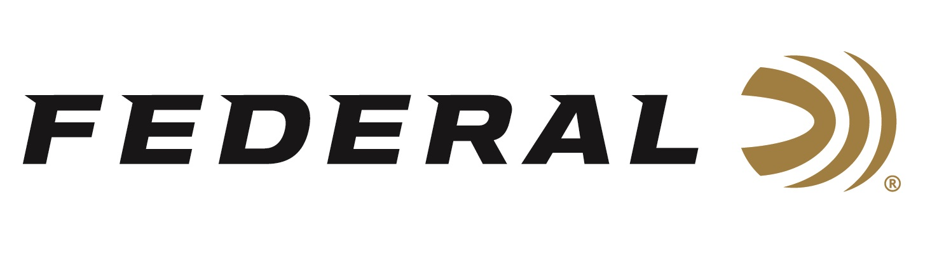

FOR IMMEDIATE RELEASE

Federal Ammunition Sponsored Shooters Austen Smith and Vincent Hancock Win Gold in Italy

ANOKA, Minnesota – July 18, 2023 – Federal Ammunition sponsored shooters Austen Smith and Vincent Hancock won Gold in Skeet Mixed Team at the 2023 International Shooting Sport Federation (ISSF) World Cup competition, held in Lonato, Italy 8-17, 2023. Team USA defeated a team from Chile in the gold medal match on Thursday, July 13.

“Austen and Vincent have set the bar for international skeet shooting in our country and are excellent representatives for the U.S.A.,” said Federal Ammunition’s Vice President of Marketing Jason Nash. “We are happy and excited to see them reach the top of the podium at this major event. Their accomplishments reflect their talent and dedication. They are a great fit for Team Federal.”

The medals won at this match add to an already accomplished-filled 2023 shooting season for Hancock, a three-time Olympic gold medalist, and Smith, a 2022 World Champion and Olympian. Hancock, a Georgia native and Smith, a native of Keller, Texas, earned the 2023 USA Shooting National Skeet Championship Men’s and Women’s titles earlier this year at Hillsdale College in Michigan.

Federal ammunition can be found at dealers nationwide. For more information on all products from Federal or to shop online, visit www.federalpremium.com.

Photo Credit: ISSF

Press Release Contact: JJ Reich
Senior Manager – Press Relations
E-mail: VistaPressroom@VistaOutdoor.com

About Federal Ammunition
Federal, headquartered in Anoka, MN, is a brand of Vista Outdoor Inc., an outdoor sports and recreation company. From humble beginnings nestled among the lakes and woods of Minnesota, Federal Ammunition has evolved into one of the world's largest producers of sporting ammunition. Beginning in 1922, founding president, Charles L. Horn, paved the way for our success. Today, Federal carries on Horn's vision for quality products and service with the next generation of outdoorsmen and women. We maintain our position as experts in the science of ammunition production. Every day we manufacture products to enhance our customers' shooting experience while partnering with the conservation organizations that protect and support our outdoor heritage. We offer thousands of options in our Federal Premium and Federal® lines-it's what makes us the most complete ammunition company in the business and provides our customers with a choice no matter their pursuit.

