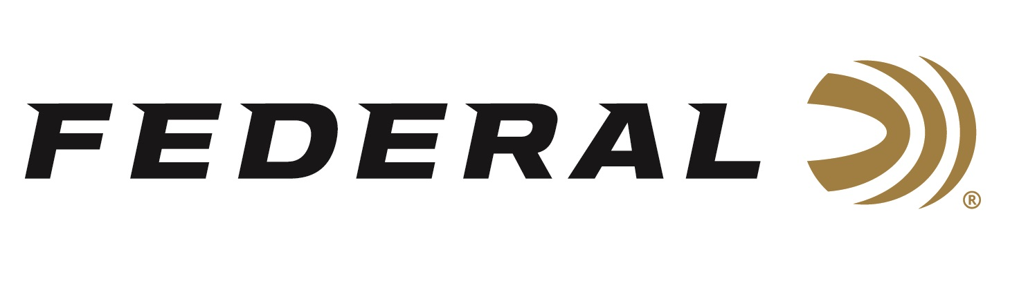
FOR IMMEDIATE RELEASE

Team Federal Shines at the Steel Classic Texas Precision Match

ANOKA, Minnesota – February 1, 2023 – Team Federal had an excellent showing at the Leupold Steel Classic Texas Precision Match held January 27-29 in Navasota, Texas. Federal sponsored shooters Cory Klemashevich took first place in the Gas Gun Division and Greg Bell won first place in the Tactical Division. The match was the first Precision Rifle Series competition of the 2023 season. There were 224 competitors total at the match.

“We build a match that we ourselves would want to shoot, we show folks true southern hospitality, and feed them the best food we can. The rest takes care of itself,” said Klemashevich, who also helps organize and run the match. “This year, we had shooters from three other countries including Norway, Mexico, and Canada. Plus, many shooters from within the U.S., from as far away as Washington, Florida, Michigan, California, and Maine. Seeing old friends and meeting new ones, really makes for a fun event.”

Klemashevich shoots Federal Premium Gold Medal Match 109-grain Berger Hybrid 6mm Creedmoor rifle ammunition.

“Conditions at this match were rainy, muddy, and windy,” said Klemashevich. “Having accurate ammo that performs reliably is always a massive advantage in any competition. Rifles will get water and grime in the chamber especially in the Gas Gun division, where pressure and dwell times can affect point of impact, and bolt velocity can affect reliability. There is no question that the Gold Medal Match product line is the most consistent precision ammo available. I certainly relied upon it during this match, and I am happy with the results.”

Federal ammunition can be found at dealers nationwide. For more information on all products from Federal or to shop online, visit www.federalpremium.com.

Press Release Contact: JJ Reich
Senior Manager – Press Relations
E-mail: VistaPressroom@VistaOutdoor.com

About Federal Ammunition
Federal, headquartered in Anoka, MN, is a brand of Vista Outdoor Inc., an outdoor sports and recreation company. From humble beginnings nestled among the lakes and woods of Minnesota, Federal Ammunition has evolved into one of the world's largest producers of sporting ammunition. Beginning in 1922, founding president, Charles L. Horn, paved the way for our success. Today, Federal carries on Horn's vision for quality products and service with the next generation of outdoorsmen and women. We maintain our position as experts in the science of ammunition production. Every day we manufacture products to enhance our customers' shooting experience while partnering with the conservation organizations that protect and support our outdoor heritage. We offer thousands of options in our Federal Premium and Federal® lines-it's what makes us the most complete ammunition company in the business and provides our customers with a choice no matter their pursuit.

