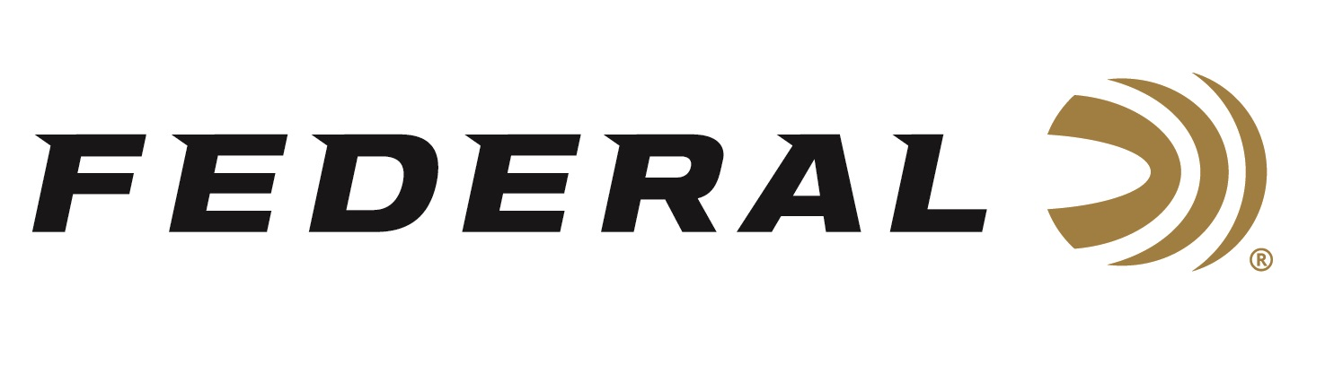

FOR IMMEDIATE RELEASE

Federal Ammunition Sponsored Shooters Shine at the 2023 World Skeet Championships

ANOKA, Minnesota – October 11, 2023 – Federal Ammunition congratulates all their sponsored shooters who participated at the 2023 World Skeet Championships, September 29 through October 6, 2023, held at the National Shooting Complex in San Antonio, Texas.

Melissa Barringer won High Over All honors at both the Mini World and Main World events. She also won the Ladies 12 gauge Champion and Ladies Doubles Runner-Up titles at the Mini World event; Ladies 12 gauge Champion and 28-gauge Runner-Up titles at the Main World event; and more.

“I’m honored to be the 2023 Mini World and World Skeet Ladies High-Overall Champion. I have worked continuously for the last few years, on and off, the field to improve in this amazing sport and I’m excited to see what the future holds for me,” said Barringer. “I am proud to represent a company who provides the market’s most consistent and reliable shotgun shells and continues to support the growth of the shooting sports industry.”

Other Main World event highlights included: Paul Giambrone winning first place at the Federal Doubles Championship; and Stuart Brown taking third at the Krieghoff 12-gauge Championship and fourth in the High All Around.

Other Mini World event highlights included: Mark Vaillancourt winning first place at the Negrini 20-gauge Championship; Paul Giambrone winning Runner-Up at the 12-gauge Championship; Cameron Schuster taking third at the Wayne Mayes Championship; and Stuart Brown taking third at the Negrini 20-gauge Championship.

“We are fortunate to have elite shooters like these represent Federal Ammunition on the world stage,” said Jason Nash, V.P. of Marketing at Federal Ammunition. “Their performances were outstanding, we know they had fun, plus their accomplishments and personal experiences are a great endorsement for our reliable and effective products.”

Federal is the number one choice for shotgun shells and manufactures products in America for all competitive and recreational disciplines. See the full lineup, including the latest High Over All, at www.federalpremium.com.

Federal ammunition can be found at dealers nationwide. For more information on all products from Federal or to shop online, visit www.federalpremium.com.

Press Release Contact: JJ Reich
Senior Manager – Press Relations
E-mail: VistaPressroom@VistaOutdoor.com

About Federal Ammunition
Federal, headquartered in Anoka, MN, is a brand of Vista Outdoor Inc., an outdoor sports and recreation company. From humble beginnings nestled among the lakes and woods of Minnesota, Federal Ammunition has evolved into one of the world's largest producers of sporting ammunition. Beginning in 1922, founding president, Charles L. Horn, paved the way for our success. Today, Federal carries on Horn's vision for quality products and service with the next generation of outdoorsmen and women. We maintain our position as experts in the science of ammunition production. Every day we manufacture products to enhance our customers' shooting experience while partnering with the conservation organizations that protect and support our outdoor heritage. We offer thousands of options in our Federal Premium and Federal® lines-it's what makes us the most complete ammunition company in the business and provides our customers with a choice no matter their pursuit.

