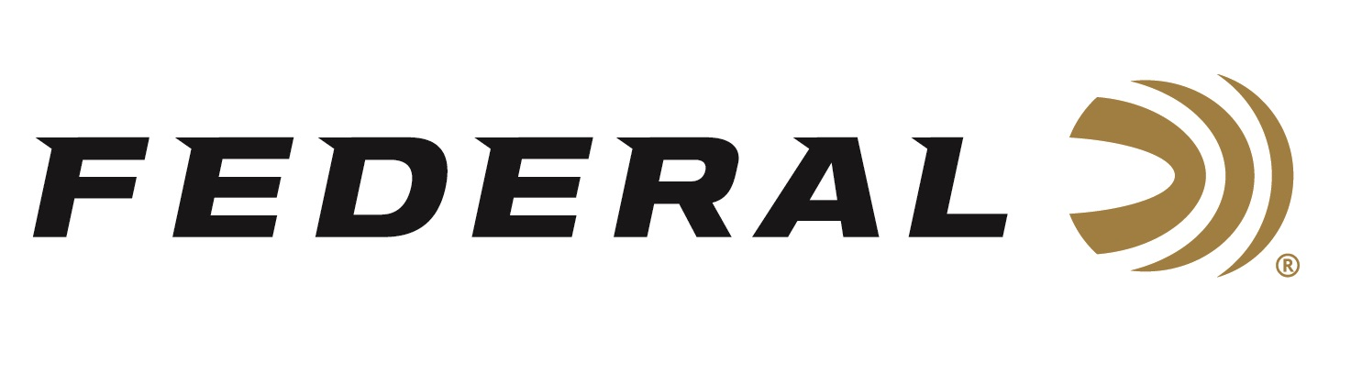

FOR IMMEDIATE RELEASE

Federal Ammunition Awards 2023 Tom Knapp Memorial Scholarships

ANOKA, Minnesota – June 28, 2023 – Federal Ammunition recently awarded the 2023 Tom Knapp Memorial Scholarships to two 4-H student ambassadors: Ryer Roberts from Colorado and Colt Shackley from Nevada. The scholarships were presented to the recipients at the National 4H Shooting Sports Invitational held in Grand Island, Nebraska June 26-30. During the opening ceremonies on June 26th Jon Zinnel, Senior Manager of Youth Shooting Programs for Federal Ammunition, announced the winners.

“As a former National 4H Ambassador myself, reviewing these applications is a highlight to my year. All these Ambassadors are tremendous citizens which made the decision challenging,” said Jon Zinnel. “Both Ryer and Colt demonstrated an impressive understanding of how wildlife is managed, plus how hunting and shooting sports programs play a vital role in operating and funding the North American Model of Wildlife Conservation in our country.”

This annual scholarship program was created to honor legendary exhibition shooter Tom Knapp, who passed away in April 2013. In 2016, Federal Ammunition and Champion Traps & Targets teamed with the National 4-H Shooting Sports Committee to continue the Tom Knapp Memorial Scholarship program. Knapp, a vocal advocate for supporting the next generation, was a long-time ambassador for both Champion and Federal Premium Ammunition. With the support of Knapp’s wife, Colleen, Champion extended Tom’s licensed products program to fund an endowed scholarship that awards $2,500 each to two National 4-H Ambassadors per year.

Federal ammunition can be found at dealers nationwide. For more information on all products from Federal or to shop online, visit www.federalpremium.com.

Pictured: Colt Shackley (left) and Jon Zinnel (Right).

Press Release Contact: JJ Reich
Senior Manager – Press Relations
E-mail: VistaPressroom@VistaOutdoor.com

About Federal Ammunition
Federal, headquartered in Anoka, MN, is a brand of Vista Outdoor Inc., an outdoor sports and recreation company. From humble beginnings nestled among the lakes and woods of Minnesota, Federal Ammunition has evolved into one of the world's largest producers of sporting ammunition. Beginning in 1922, founding president, Charles L. Horn, paved the way for our success. Today, Federal carries on Horn's vision for quality products and service with the next generation of outdoorsmen and women. We maintain our position as experts in the science of ammunition production. Every day we manufacture products to enhance our customers' shooting experience while partnering with the conservation organizations that protect and support our outdoor heritage. We offer thousands of options in our Federal Premium and Federal® lines-it's what makes us the most complete ammunition company in the business and provides our customers with a choice no matter their pursuit.

