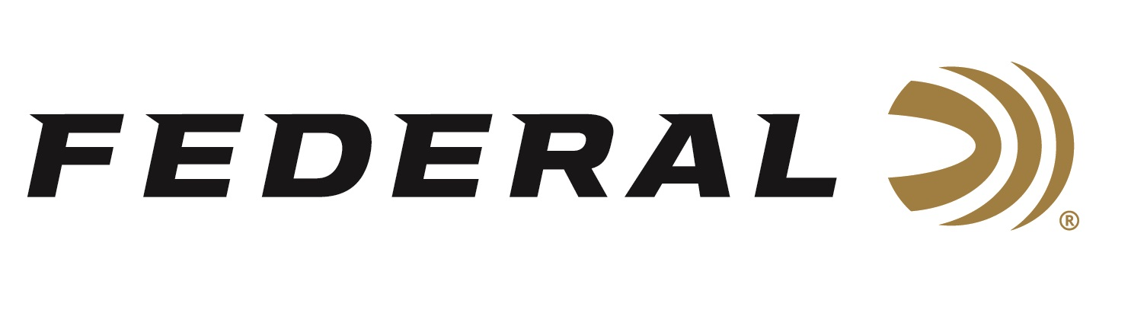

FOR IMMEDIATE RELEASE

Federal Ammunition Adds New Train + Protect 10mm Auto

ANOKA, Minnesota – May 31, 2023 – Federal recently added a new line extension to its popular and versatile Train + Protect product line—which features packaging that honors any shooter’s birthright to bear arms—with a new load in 10mm Auto. The full-power 10mm offering features a Versatile Hollow Point (VHP) bullet to deliver both precise, practical performance at the range, and instant, reliable expansion on impact.

Train + Protect | Federal Ammunition (federalpremium.com)

“With the popularity of our Train +Protect products and customers desire to have a good all-around option they can use for training as well as protection, we’re expanding the line with 10mm auto,” said Federal’s Handgun Product Line Director Nick Sachse. “10mm has seen a resurgence in recent years and we continue to receive requests for more options in the cartridge.”

Summary of features include: New 180-grain 10mm Auto load; VHP bullets based on proven Federal versatile hollow-point design; Reloadable Federal brass case; Extremely reliable primer; Loaded to produce consistent performance on the range and in defense situations; 50-count boxes; MSRP: $57.99.

For more information on all products from Federal or to shop online, visit www.federalpremium.com.

Press Release Contact: JJ Reich
Senior Manager – Press Relations
E-mail: VistaPressroom@VistaOutdoor.com

About Federal Ammunition
Federal, headquartered in Anoka, MN, is a brand of Vista Outdoor Inc., an outdoor sports and recreation company. From humble beginnings nestled among the lakes and woods of Minnesota, Federal Ammunition has evolved into one of the world's largest producers of sporting ammunition. Beginning in 1922, founding president, Charles L. Horn, paved the way for our success. Today, Federal carries on Horn's vision for quality products and service with the next generation of outdoorsmen and women. We maintain our position as experts in the science of ammunition production. Every day we manufacture products to enhance our customers' shooting experience while partnering with the conservation organizations that protect and support our outdoor heritage. We offer thousands of options in our Federal Premium and Federal® lines-it's what makes us the most complete ammunition company in the business and provides our customers with a choice no matter their pursuit.

