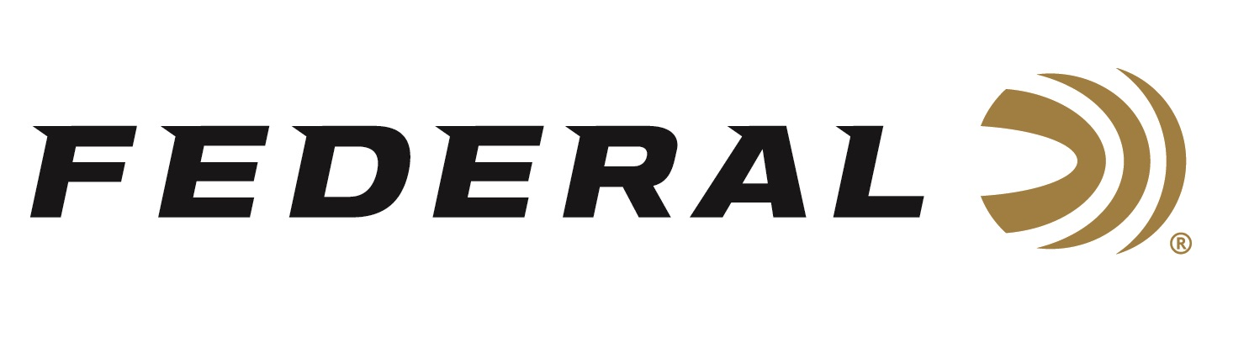

FOR IMMEDIATE RELEASE

Federal Ammunition Shooters Gregg Wolf and Cameron Hicks
Shoot Strong at the American Grand Prix

ANOKA, Minnesota – May 8, 2023 – Federal Ammunition congratulates sponsored shooters Gregg Wolf and Cameron Hicks on their strong performances at the American Grand Prix and Trident Cup. The event was held May 4-7 at Meadows Clay Sports in Forsyth, Georgia.

In the Grand Prix, Wolf earned the FITASC High Overall Runner-Up honors after posting a score of 188/200 and falling short in a shoot-off. Hicks placed 8th overall in Grand Prix and then secured M1 in a final shoot-off in the Sporting Main division. Both shooters relied on Federal’s High Over All competition-grade target loads.

“We are proud to sponsor top-level shooters on Team Federal this year,” said Federal Ammunition’s Vice President of Marketing, Jason Nash. “Their performances and accomplishments reflect Federal’s dedication to its quality products and commitment to the shooting sports.”

Federal Premium High Over All is engineered for the most elite trap, skeet, and sporting clays shooters. These quality target loads leave a trail of shattered clays in its wake and more reloads per shell. It’s hard, high-antimony lead payload and wad produce the most consistent patterns, while the solid brass head and hull design make reloading easier than ever.

High Over All is available in a wide variety of 12-, 20- and 28-gauge options, plus .410 bore: delivering an option for any discipline of competitive target shooting. It’s the ultimate competition load for the world’s best shooters.

Federal ammunition can be found at dealers nationwide. For more information on all products from Federal or to shop online, visit www.federalpremium.com.

Press Release Contact: JJ Reich
Senior Manager – Press Relations
E-mail: VistaPressroom@VistaOutdoor.com

About Federal Ammunition
Federal, headquartered in Anoka, MN, is a brand of Vista Outdoor Inc., an outdoor sports and recreation company. From humble beginnings nestled among the lakes and woods of Minnesota, Federal Ammunition has evolved into one of the world's largest producers of sporting ammunition. Beginning in 1922, founding president, Charles L. Horn, paved the way for our success. Today, Federal carries on Horn's vision for quality products and service with the next generation of outdoorsmen and women. We maintain our position as experts in the science of ammunition production. Every day we manufacture products to enhance our customers' shooting experience while partnering with the conservation organizations that protect and support our outdoor heritage. We offer thousands of options in our Federal Premium and Federal® lines-it's what makes us the most complete ammunition company in the business and provides our customers with a choice no matter their pursuit.

