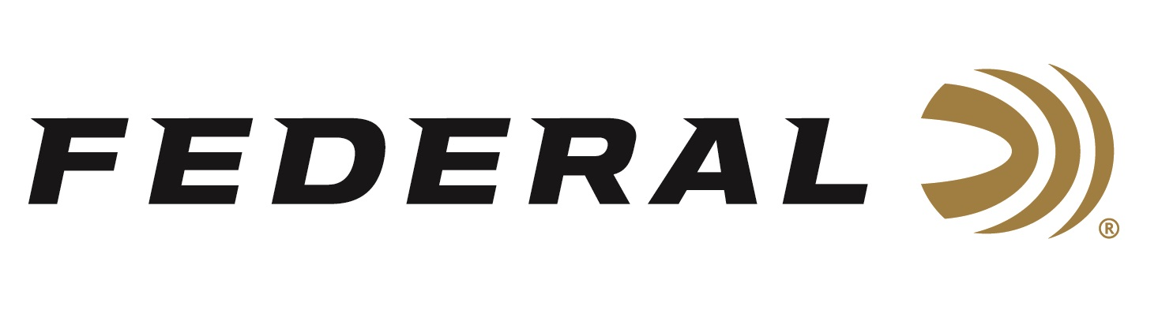

FOR IMMEDIATE RELEASE

Ready for Summer: New Federal Ammo T-Shirts & Hats

ANOKA, Minnesota – June 8, 2023 – Loved by hunters and shooters across the country, Federal Ammunition has added to its comprehensive line of high-quality branded gear for sale direct to consumer. The merchandise includes men’s and women’s apparel, home décor, hunting gear, range gear, educational tools, gifts and more. Several new t-shirt and hat designs have recently been added, just in time for summer.

“These new t-shirts are comfortable and lightweight. Their cool, modern designs are also branded with the Federal logo, making them perfect for any fan of every type of ammunition,” said Melissa Bang, Federal’s Digital & E-Commerce Director. “Their popular colors and bold graphics make them ideal for any casual occasion. So, whether you’re outdoors relaxing at a backyard BBQ, shooting a round at a sporting clays course, practicing your handgun skills at an indoor range, or just out on the town for a fun evening; you'll feel stylish and comfortable in any of our new t-shirts.”

The Federal Eagle Bullet T-Shirt features an eagle design with a bullet in the center, hinting at love for the U.S.A. and ammo. The Federal Ballistic T-Shirt features just a simple logo on the front, perfect for anyone who loves Federal ammo. The Federal Flag T-Shirt is a fantastic way to show patriotic pride and support for the U.S.A., featuring letters in the colors of the American flag.

All of Federal’s short-sleeve T-shirts are extremely comfortable and breathable. They are made of either 60% combed ring-spun cotton and 40% polyester, or 90% combed ring-spun cotton and 10% polyester. Their classic fit allows for easy movement during any activity. They come in Men’s sizes: Small, Medium, Large, XL, 2XL, and 3XL.

“We have also added a few new hats. My favorite is the Federal Deer Skull Hat,” said Bang, “It’s perfect for those who love the outdoors and want to show it! The deer skull image is iconic and the Federal ammo brand is a trusted name. The moss and black mesh add to the rugged look and make this hat great for any adventure.”

With items added frequently—alongside exciting sales and promotions—customers are encouraged to check Federal’s Merchandise section on the company’s web site regularly to see what’s new: https://www.federalpremium.com/merchandise/apparel/

For more information on all products from Federal or to shop online, visit www.federalpremium.com.

Press Release Contact: JJ Reich
Senior Manager – Press Relations
E-mail: VistaPressroom@VistaOutdoor.com

About Federal Ammunition
Federal, headquartered in Anoka, MN, is a brand of Vista Outdoor Inc., an outdoor sports and recreation company. From humble beginnings nestled among the lakes and woods of Minnesota, Federal Ammunition has evolved into one of the world's largest producers of sporting ammunition. Beginning in 1922, founding president, Charles L. Horn, paved the way for our success. Today, Federal carries on Horn's vision for quality products and service with the next generation of outdoorsmen and women. We maintain our position as experts in the science of ammunition production. Every day we manufacture products to enhance our customers' shooting experience while partnering with the conservation organizations that protect and support our outdoor heritage. We offer thousands of options in our Federal Premium and Federal® lines-it's what makes us the most complete ammunition company in the business and provides our customers with a choice no matter their pursuit.

