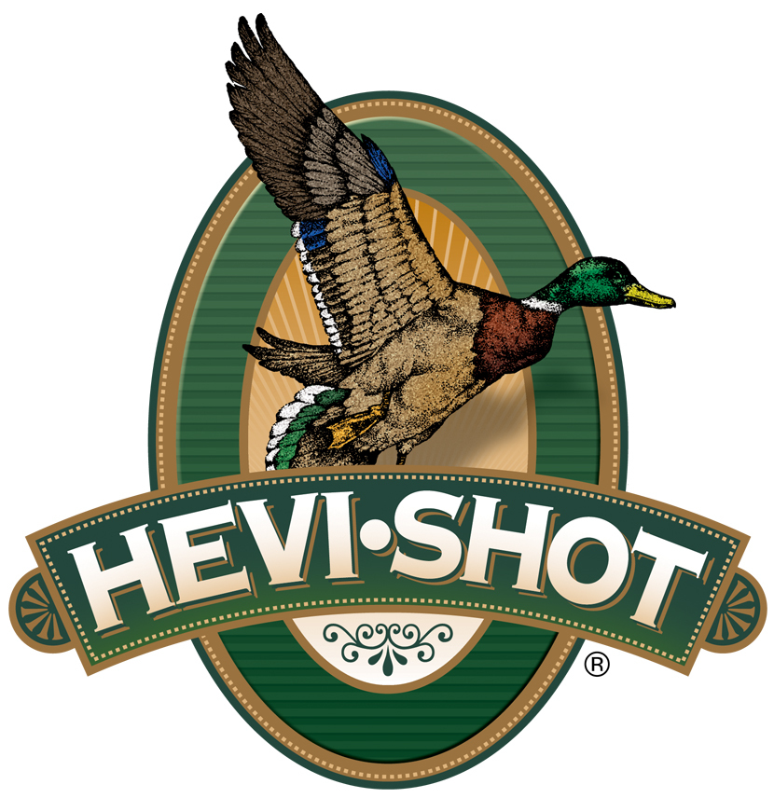

FOR IMMEDIATE RELEASE

HEVI-Shot Ammunition Introduces New HEVI-18 Turkey Loads for 2023

SWEET HOME, Oregon – September 14, 2023 – HEVI-Shot is proud to announce new line extensions to its HEVI-18 Tungsten Super Shot (TSS) product line which brings best-in-class performance to the turkey market with 18 g/cc density pellets in No. 7 and 9 shot. The loads provide high pellet counts, long-range lethality, and incredibly tight patterns. Four new loads are now offered in 2-3/4-inch, reduced-recoil 12- and 20-gauge loads, as well as two 3-inch, 28-gauge options.

HEVI-18 TSS Turkey | Hevi Shot

“3-inch and 3-1/2-inch 12-gauge loads are commonplace in the turkey hunting world. But for 2023, we are excited for the introduction of our new reduced recoil 2-3/4-inch loads,” said HEVI-Shot product manager Scott Turner. “With the use of TSS, the shorter hull size delivers the ability to reduce the felt recoil, yet still have impressive results downrange. These new loads are ready for wild turkey hunting seasons this fall.”

HEVI-Shot’s HEVI-18 Turkey product line now consists of twelve total load options, available in 12-, 20-, or 28-gauge, and .410 bore.

“As far as our new 28-gauge loads go, this was 100-percent a selfish product on my end,” continued Turner. “I have really enjoyed shooting my Benelli Super Black Eagle 3 in 28-gauge, and I want to use it turkey hunting this fall. I think it’s the perfect stop gap between 410 bore and 20-gauge. We predict the 28-gauge will be the hot topic for wild turkey hunters in fall 2023 and spring 2024.”

The new ammunition products are loaded in Sweet Home, Oregon, U.S.A. in 5-round boxes; MSRP: $59.99 to $72.99 depending on product/gauge.

For more information on all products from HEVI-Shot, visit www.hevishot.com.

Press Release Contact: JJ Reich
Senior Manager – Press Relations
E-mail: VistaPressroom@VistaOutdoor.com

About HEVI-Shot
Established in 2000 and based out of Sweet Home, Oregon, HEVI-Shot is a brand of Vista Outdoor Inc., an outdoor sports and recreation company. HEVI-Shot is an industry leader in performance shotshell, providing the next generation of shotshell loads to hunters—with their large and impressive selection of hunting ammunition options. HEVI-Shot is synonymous with high performance projectiles. The company meticulously designs each product to outperform any ammunition competitor in its class. That is why HEVI-Shot is the ammunition choice for serious hunters who live by their slogan: “I DIDN’T COME THIS FAR TO MISS!”

